**“THE VITM | Version 2.0”**

**A PROJECT REPORT SUBMITTED IN PARTIAL FULFILLMENT OF REQUIREMENT**

**FOR THE DEGREE OF**

**BACHELOR OF TECHNOLOGY**

**IN**

**COMPUTER SCIENCE ENGINEERING**

**SUBMITTED BY**

**D. Binod 2101301034**

**Biswaprakash Biswal 2101301029**

**UNDER THE ESTEEMED GUIDANCE OF**

**Prof. Pradhan Bage**

**Dept. Of Computer Science of Engineering**



**DEPARTMENT OF**

**COMPUTER SCIENCE ENGINEERING**

**VIGNAN INSTITUTE OF TECHNOLOGY AND MANAGEMENT**

**BERHAMPUR-761008**



**CERTIFICATE**

This is to certify that we have examined the project entitled **“THE VITM”** has been submitted by **D.BINOD,**bearing Registration Number **2101301034** under my guidance in partial fulfilment of the degree of Bachelor of Technology in **Computer Science Engineering** of Biju Pattnaik University of Technology, Rourkela during the academic year 2023-2024.

This is for the partial fulfilment of the requirement of the Bachelor of Technology in **Computer Science Engineering**, **Vignan Institute of Technology and Management, Berhampur** under Biju Pattnaik University of Technology.

|  |  |  |
| --- | --- | --- |
| **Signature of Guide** | **Signature of External Examiner** | **Signature of HOD** |
| **Prof. PRADHAN BAGE** |  | **Prof. B.SRINIVAS RAO** |
| **VITAM, Berhampur** |  | **(Prof. & Head,CSE,EEE)** |

**ACKNOWLEDGEMENT**

This work was completed due to the grace of almighty god we are highly indebted to god that he has given the strength and encouragement to complete this work and hope his blessings will continue to be showered on us so that we can achieve the goal of our lives.

We avail this opportunity to place my profound gratitude to my guide **Prof. PRADHAN BAGE,** Department of **Computer Science Engineering** for his constant supervision, inspiration and encouragement, right from the beginning of the seminar report entitled **“THE VITM”.**

We also indebted to **Prof. B.SRINIVAS RAO** , HOD of Computer Science Engineering for his help and advice in completion of this seminar report.

Finally, we would like to extend my sincere thanks to all my friends and all persons who have rendered their valuable help directly or indirectly in the completion of this seminar report.

**D. Binod**

**2101301034**

**Department of Computer Science Engineering**

**DECLARATION**

We do hereby that declare we have undergone a project on **“THE VITM”** at **Vignan Institute Of Technology And Management, under** the guidance **Prof. Pradhan Bage, department** of **Computer Science Engineering, Vignan Institute of Technology and Management**, Berhampur.

We submit this report in partial fulfilment of the requirement for the Bachelor in Technology in **Computer Science Engineering** from **Vignan Institute of Technology and Management**, Berhampur. The report is exclusively & comprehensively prepared & conceptualized by us. All the information & data given here in this project are collected during our study from sources & it has not been published anywhere before.

**D. Binod**

**2101301034**

**Department of Computer Science Engineering**

**ABSTRACT**

The **THE** **VITM, Version 2.0**, is a comprehensive digital platform designed to significantly elevate the digital operations and user experience of VITM Institute. It modernizes the institution’s online presence and enhances accessibility, communication, and convenience for all stakeholders—students, faculty, administrative staff, and prospective applicants. The primary goal of this upgraded application is to address the limitations of the previous version by introducing a dynamic, user-centric interface combined with a robust and efficient backend architecture. These improvements create a more interactive, responsive, and scalable platform that can adapt to the evolving needs of an educational institution.

Key features of the VITM Web Application include **interactive modules for Admissions, Examination Management, Syllabus Access, Results, Events, Announcements, and Staff & Faculty Information**. Each of these modules is tailored to address specific needs within the institute, offering a self-service approach that reduces the reliance on administrative support. For instance, the Admissions module provides prospective students with application forms, eligibility criteria, and deadlines, while the Examination module enables students to view schedules and results, contributing to a streamlined academic journey.

The updated application also **prioritizes communication**, implementing notification and announcement features to keep students and staff informed of critical updates. This enables real-time dissemination of information on new events, policy changes, deadlines, and emergency notices, fostering a more connected and informed community. Furthermore, the Events section highlights upcoming academic, cultural, and sports events, allowing users to view details, RSVP, and participate.

Security is a central focus of VITM 2.0, incorporating **advanced security protocols** to protect user data and ensure compliance with regulatory standards. The application implements role-based access control (RBAC), which restricts access based on user roles (e.g., student, faculty, admin), ensuring that sensitive data remains secure. Additional security measures, such as encrypted communication and regular security audits, further strengthen data protection and user trust.

**CONTENTS**

|  |  |  |
| --- | --- | --- |
| **Chapters Names Page no** | |  |
| 1. **Introduction 1-4** | |
| * 1. The Need for VITM   2. Trends in EWT  1. **Project Objectives & Scope 5-8**   2.1 project objectives  2.2 project scope   1. **System Analysis and Requirement Specification 9-20**   3.1 analysis of user requirement  3.2 fun & non-fun requirement  3.3 use case &user scenarios for each module   1. **Domain Name register 16-18**   4.1 Introduction  4.2 Selection Domain name  4.3 Domain Extensions  4.4 Domain Registration Process  4.5 Domain Privacy Protection  4.6 Benefits of DNR  **5**. **Technology Stack 19-25**  5.1 Fronted  5.2 Backend  5.3 Databa  5.4 Other tools  5.5 Justification  **6. System Design 26-34**  6.1 System Architecture  6.2 Microservice or Modular Design  6.3 User Interface Design  6.4 Database Design  **7. System Development 35-36**  7.1 Backend Development  7.2 Frontend Development  **8. Database Management 37-40**  8.1 Database Design  8.2 Database Schema  8.3 Data Integrity & Constraints  8.4 Data Access & Management  8.5 Database Backup & Recovery  8.6 Security & compliance  **9. Testing & Quality Assurance 41-42**  **10. Deployment Strategy 43**  **11. Security Consideration 44**  **12. Total cost Estimation 45-46**  12.1 Overview  12.2 Breakdown of Costs  **13.** **Maintenance & Future Scope 47**  13.1 Maintenance Plan  13.2 Potential Future Features  13.3 Recommendation For Scalability  **14.** **Deployment Project 48**  14.1 Overview  14.2 Deployment Process  **15.** **Project Timeline & Development Workflow 49-51**  15.1 Project Timeline with Development  15.2 Gantt Chart or Timeline Diagram  15.3 Agile Development Methodology  15.4 GitHub For Version Control & Collab  15.5 Team Collaboration  **16.conclusion & Recommendations 52-54**  **17.** **Reference 55** | |
|  | |
|  | |
|  | |
|  | |  |
|  | |  |
|  | |  |
|  | |  |
|  | |  |
|  |

**LIST OF FIGURES**

|  |  |  |  |  |  |
| --- | --- | --- | --- | --- | --- |
| **Serial No.** | **Figure No.** | | | **Figure Caption / Description** | **Page No.** |
| 01 | Fig (1.1-2.2) | | |  | 1-12 |
| 02 | Fig (2.3-3.1) | | |  | 19-23 |
| 03 | Fig (3.2-4.8) | | |  | 26-32 |
| 04 | Fig (4.9-5.0) | | |  | 49-52 |
|  | |  |
|  | |  |
|  | |  |
|  | |  |
|  | |  |
|  | |  |

|  |  |  |  |  |
| --- | --- | --- | --- | --- |
| **Serial No.** | | **Table No.** | **Table Caption / Description** | **Page No.** |
| 01 | | Table-1.1 | Cost Estimation | 49 |
|  | |
|  |
|  |
|  | |  |  |  |

**LIST OF TABLES**

**CHAPTER -1**

**INTRODUCTION**

In today's digital landscape, an educational institution website serves as the primary gateway through which the public, prospective students, current students, and staff engage with the institution. For any educational organization, the website acts as an essential tool for communication, information dissemination, and operational support. As educational institutions grow in both size and complexity, their websites need to meet increasingly diverse requirements: providing quick access to academic resources, supporting admissions processes, and serving as an information hub for various stakeholders.

* 1. **The Need for VITM**

With the rapid advancements in digital technology, VITM Institute recognized the need to enhance its digital platform to better serve its community. The current web application had grown outdated in both functionality and design, presenting challenges in terms of user experience, scalability, and security. The institute’s digital transformation strategy called for an updated platform that could address these limitations and meet the demands of a modern educational institution. The launch of **Version 2.0** for the VITM Web Application is a response to these needs, providing a solution that aligns with the institution’s goals for technological advancement and user satisfaction.

**Key motivations for upgrading to Version 2.0 include:**

* **Improved User Experience**: The previous version had a static and often cumbersome design, which made it difficult for users to navigate and locate information. Version 2.0 introduces a dynamic, intuitive interface that allows users to easily access information, whether they are students checking results, parents exploring admissions, or faculty updating course materials
* **Enhanced Functionality and Modular Structure**: Unlike the previous version, which had a limited range of functions, Version 2.0 adopts a modular design, allowing for dedicated sections for Admissions, Results, Announcements, Events, and more. This modularity not only improves user experience but also provides a scalable foundation for future updates and additions.
* **Responsive and Mobile-Friendly Design**: In the previous version, the lack of mobile responsiveness limited access for users on smartphones and tablets. With the increased use of mobile devices, it became essential to develop a platform that works seamlessly on all screen sizes. Version 2.0 incorporates responsive design principles, ensuring a consistent experience across devices.
* **Robust Backend and Database Improvements**: In Version 1.0, backend limitations affected data retrieval speed and security. The upgrade to Version 2.0 includes a more powerful backend infrastructure that supports faster loading times, improved data handling, and a higher level of data security.
* **Enhanced Security**: With the increasing importance of data privacy and compliance, VITM Institute recognized the need to implement stronger security measures. Version 2.0 introduces role-based access control, encrypted data storage, and other features that align with data protection regulations, providing a safe environment for sensitive academic and personal information.
* **Better Support for Real-Time Updates**: As a dynamic institution, VITM frequently updates students and staff on events, deadlines, and academic schedules. The previous website lacked an effective system for real-time updates, which sometimes led to communication gaps. Version 2.0 includes notification and announcement features that keep all users up-to-date on the latest developments.
  1. **Trends in Educational Web Technology**

Web application development for educational institutions has evolved significantly over recent years, influenced by advances in web technologies and a growing emphasis on user experience and accessibility. The trend toward digital transformation in education is driven by the need for flexibility, efficient resource management, and data-driven decision-making. These advancements have reshaped how educational institutions interact with students, faculty, and the broader community, with several key trends emerging as part of this evolution.

* **Responsive Design and Mobile Accessibility**: As mobile internet use continues to grow, educational web applications increasingly prioritize responsive design to ensure accessibility on smartphones, tablets, and other mobile devices. Modern web applications are built to automatically adjust to different screen sizes and orientations, providing users with a seamless experience across all devices. This trend reflects a broader shift toward user-centered design, where applications are created to meet the needs of users on various devices and platforms.
* **Integration with Cloud Computing**: Cloud-based solutions have become a standard in educational technology, offering scalability, flexibility, and cost-effectiveness. By leveraging cloud infrastructure, educational web applications can handle large volumes of data while providing faster and more reliable performance. Cloud integration also enables easier updates, backups, and remote access, ensuring that institutions can deliver consistent services to users anywhere, anytime.
* **Enhanced Security and Data Privacy**: With growing concerns over data security and privacy, educational institutions are implementing stricter security protocols in their web applications. Compliance with data protection regulations.

**CHAPTER -2**

**Project Objectives & Scope**

**2.1 Project Objectives**

The VITM Web Application, Version 2.0, is designed with specific goals to create a highly functional, accessible, and user-centered platform that addresses the needs of students, faculty, staff, and prospective applicants. The primary objectives of this project focus on enhancing the overall user experience and supporting the institution’s academic and administrative functions. Below are the main objectives:

* **Enhance Accessibility Across Devices**

The application aims to provide a seamless experience across desktops, tablets, and mobile devices through a responsive design. This ensures that all users, regardless of their device, can access the platform efficiently. Accessibility standards are also prioritized to ensure inclusivity, meeting web accessibility guidelines to accommodate all users, including those with disabilities.

* **Improve User-Friendliness and Navigation**  
   User experience is central to Version 2.0, with a simplified and intuitive interface that allows users to locate information with ease. Clear menu structures, visual cues, and easy-to-navigate modules will minimize learning curves, ensuring that users, whether they are students or first-time visitors, can interact with the platform without confusion or difficulty.
* **Ensure Security and Data Privacy**  
  With robust security protocols, Version 2.0 will protect user data and prevent unauthorized access. The application will implement role-based access control (RBAC) and data encryption to ensure the safety of personal and academic information, adhering to data protection standards and regulations.

**2.2 Project Scope**

The scope of the VITM Web Application, Version 2.0, is defined to cover all essential modules and functionalities required by the institution’s community, while clearly setting boundaries to keep the project focused and achievable. The application’s scope includes modules that provide academic, informational, and administrative support to students, faculty, staff, and prospective students.

**The following modules and functionalities are within the defined scope of this project:**

* **Home Page**: Serves as the landing page with quick links to essential sections, announcements, and general information about VITM.
* **Admissions**: Provides information on eligibility, application processes, deadlines, and an application submission feature.
* **Syllabus and Academic Resources**: A centralized location where students and faculty can access syllabus documents, course structures, and related academic materials.
* **Examination and Results Management**: Enables students to view exam schedules and access their academic results securely.
* **Faculty and Staff Profiles**: A searchable directory displaying faculty and staff information, areas of expertise, and contact details.
* **Events and Announcements**: Dedicated sections for campus events, academic calendars, and real-time announcements with RSVP or registration features.
* **Gallery**: Visual content to showcase campus life, infrastructure, and event highlights.
* **Facilities Information**: Provides details on campus facilities such as libraries, laboratories, and sports centers.
* **Career Opportunities**: A job portal listing open positions within the institute, allowing applicants to apply directly.
* **Contact and Inquiry Support**: Contact information, inquiry form, and Google Maps integration for easy visitor navigation.
* **Error page**: Custom error page for smoother user experience, also to show the error that are occur in the execution time.
* **robots.txt File**: For controlling how search engines crawl and index site content.
* **Application Form Submission**: Includes form submission functionality with an **Email OTP Verification** to validate applicants' emails.
* **Student Fee Management System:** Fetching students fee structure, Due Amount , Total Amount and allowing to pay the due payments online.
* **Downloads page:** The forms need to download for academic use.
* **Result page:** Students can view their Semester & Mid-sem results.
* **Bus Transportation:** Managing bus route and live bus. Can be track the live location of Bus.
* **Conductor Portal:** Conductor can access and manage bus route.

**Certain features and functionalities are purposefully excluded to keep the project timeline and resources manageable:**

* **Mobile Application**: Although the web application is designed to be mobile-friendly, a dedicated mobile app for iOS or Android is outside the scope of this project.
* .
* **Social Media Integration**: While the application may link to VITM’s social media, a social media feed or live integration is not part of the current scope.

**CHAPTER -3**

**System Analysis and Requirement Specification**

**3.1 Analysis of User Requirements**

The requirements for the VITM Web Application, Version 2.0, were gathered through direct consultations with primary stakeholders: students, faculty, and administrative staff. Each group had specific needs that informed the overall design and functionality of the platform. Below is a breakdown of these requirements by stakeholder group:

* **Students**: Students require easy access to academic resources, exam schedules, results, and announcements. Their primary needs include a clear view of admission processes, up-to-date syllabi, real-time notifications for exams and events, and secure access to their grades and academic records.
* **Faculty**: Faculty members need efficient ways to access and update course-related information, manage syllabi, and view student performance data. They also require a platform to display their profiles and achievements, as well as a way to communicate announcements related to their departments.
* **Administration**: The administration team needs tools to manage admissions, events, and announcements. Their requirements include control over the backend to update website content, manage applications, organize events, and post announcements. Security and access control were particularly emphasized for administrative functions.
* **Conductor:** Conductors will be provided specific login id and password . After successful login to dashboard conductor will be accessed to provide bus live location and verify transportation is card.

**3.2 Functional and Non-Functional Requirements**

* **Functional Requirements**

These requirements define what the system should do and include specific functions for each module. The following list summarizes the core functional requirements for each major module:

* **Homepage**:
  + Display quick links to key sections like Admissions, Announcements, Events, and Contact.
  + Showcase recent announcements and upcoming events.

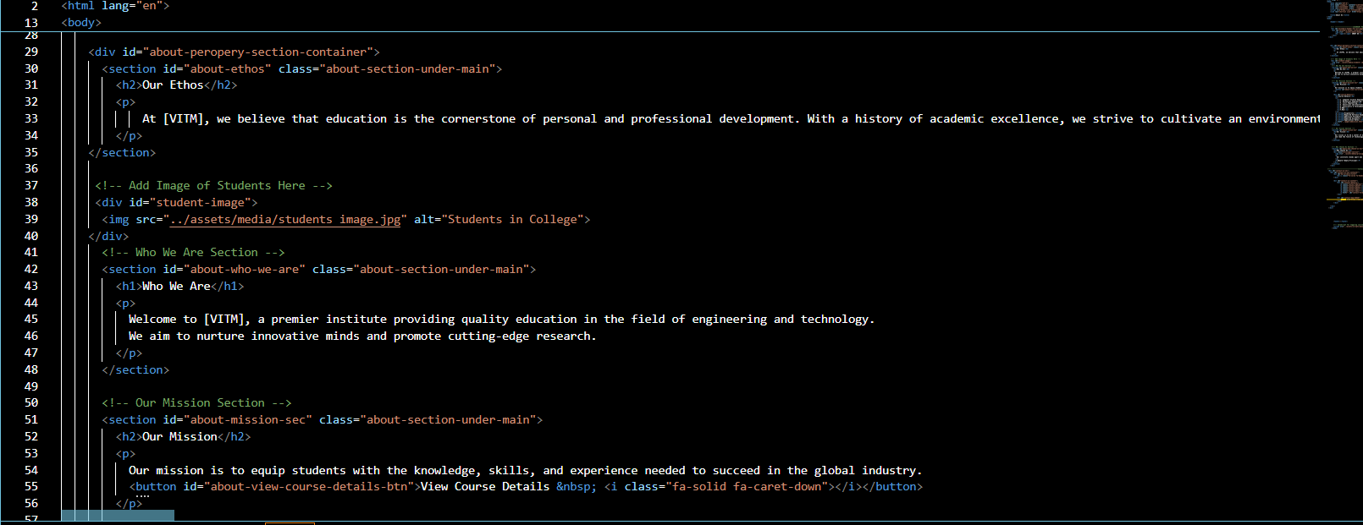

*Fig 1.1*

* **Admissions Module**:
  + Provide admissions information (eligibility, process, fees).
  + Allow users to submit applications and upload necessary documents.
  + 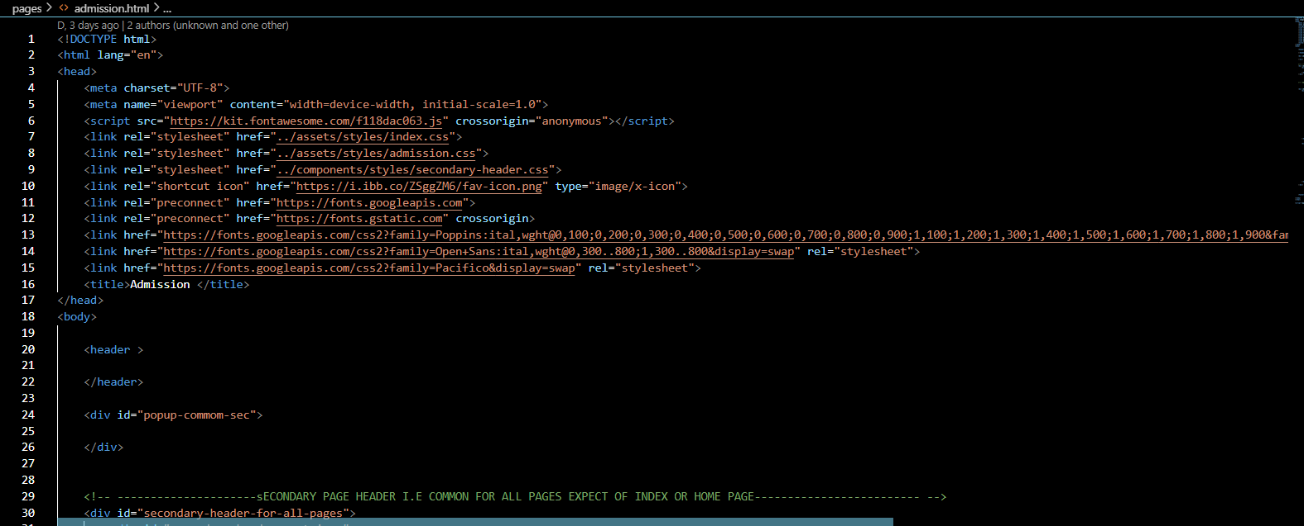Send automated confirmation emails for submitted applications.

*Fig 1.2*

* **Syllabus and Academic Resources Module**:
  + Allow students to access syllabi by course or program.
  + 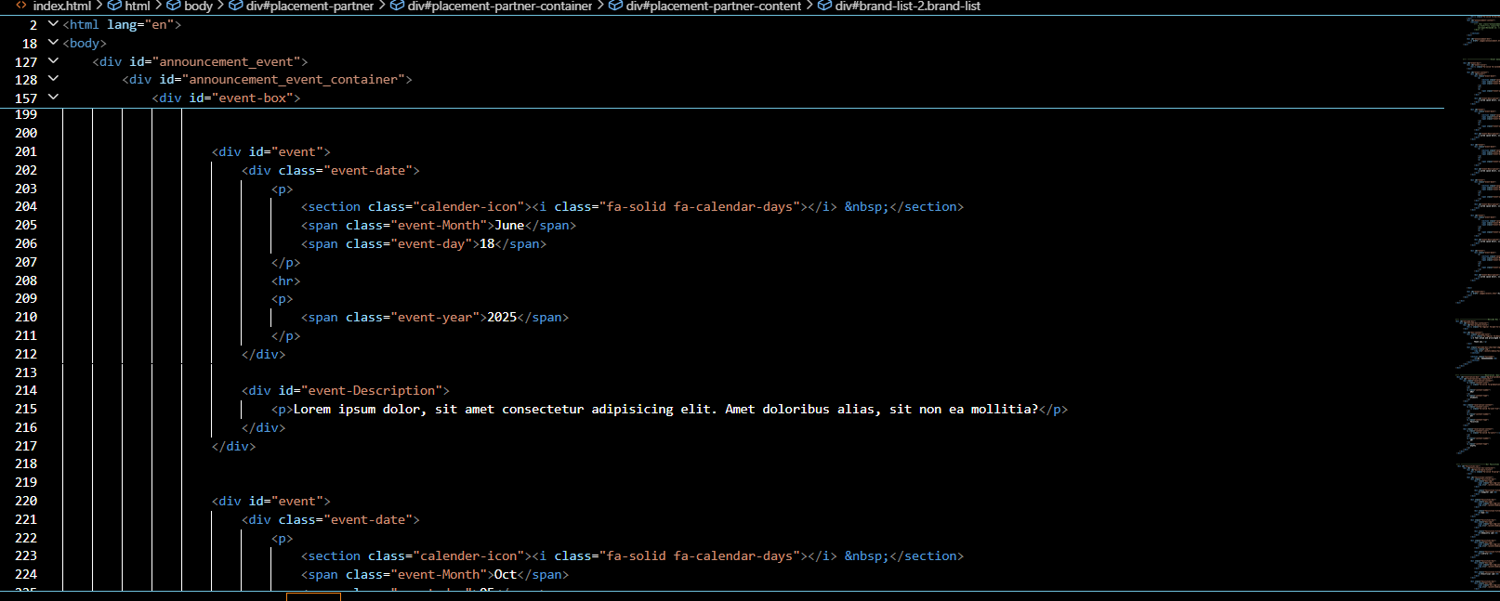Provide downloadable documents for syllabi and related academic materials.

*Fig 1.3*

* **Examination and Results Module**:
  + Display examination schedules for each academic program.
  + 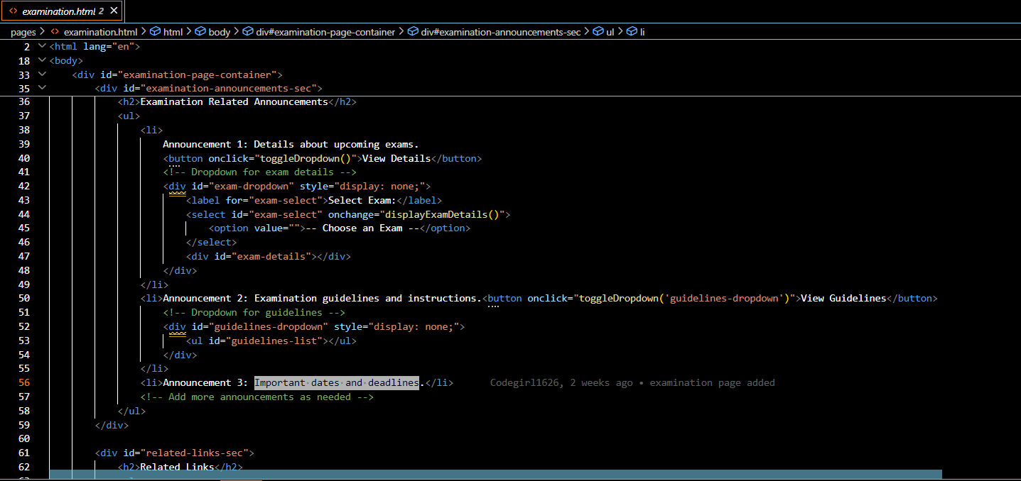Allow students to view and download exam results after secure login.

*Fig 1.4*

* **Faculty and Staff Directory**:
  + Provide searchable profiles of faculty and staff, including name, designation, department, and contact information.
  + 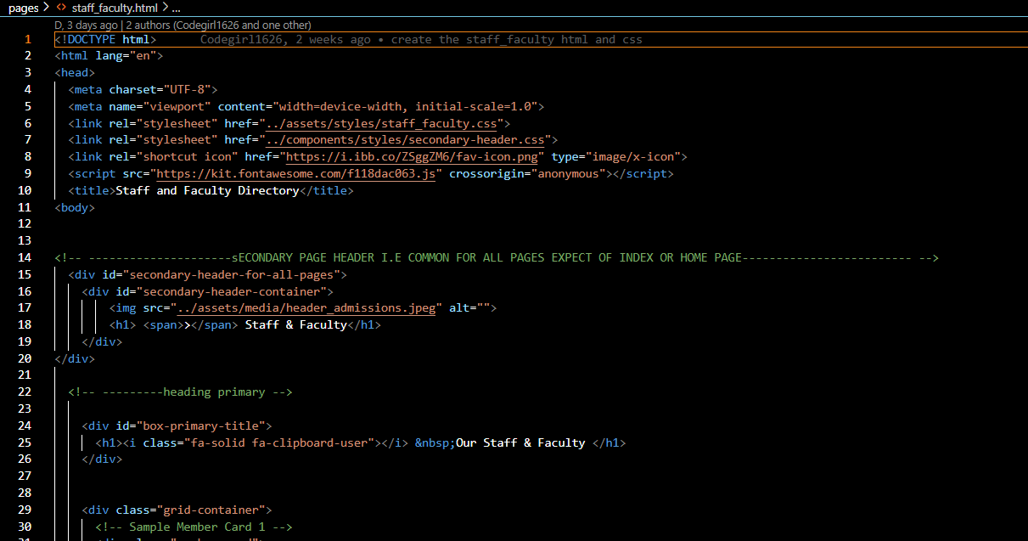Allow faculty to update their profiles and add academic qualifications, publications, and achievements.

*Fig 1.5*

* **Events and Announcements Module**:
  + Display upcoming campus events with dates, descriptions, and RSVP options.
  + Provide a central location for announcements with filters for academic and non-academic updates.
  + 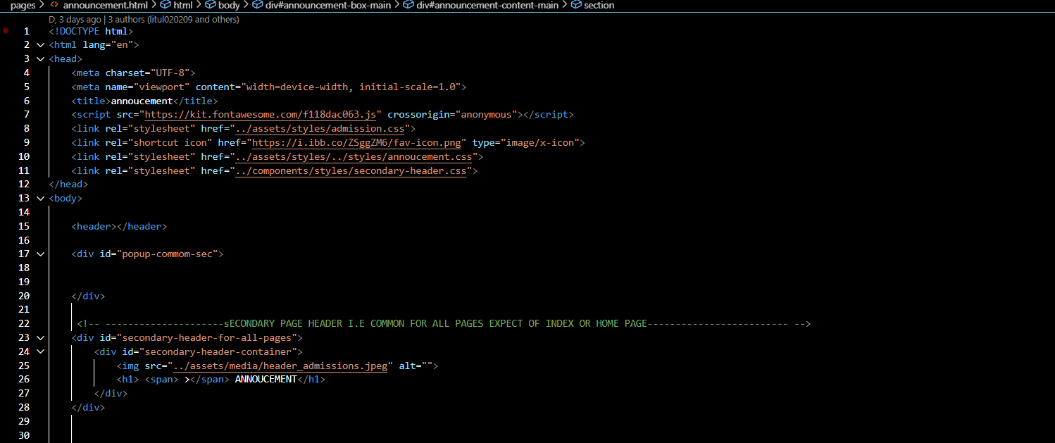This is short by data appended.

*Fig 1.6*

* **Gallery Module**:
  + Feature a gallery of images and videos showcasing campus life, events, and facilities.
  + 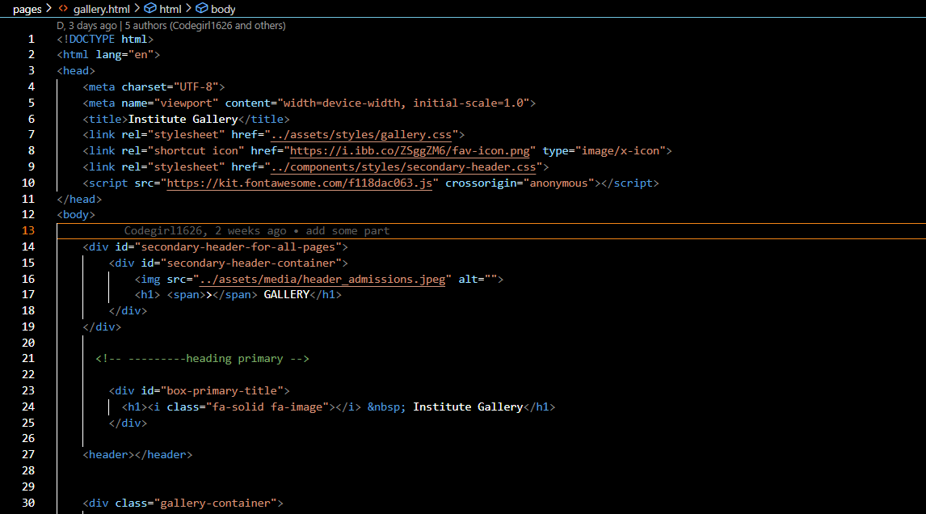Enable easy uploading and management of media files from the backend.

*Fig 1.7*

* **Contact and Inquiry Module**:
  + Provide contact details for the institution, including a Google Maps integration for location.
  + Include an inquiry form that sends user messages directly to the administrative email.
  + This is short by data appended.

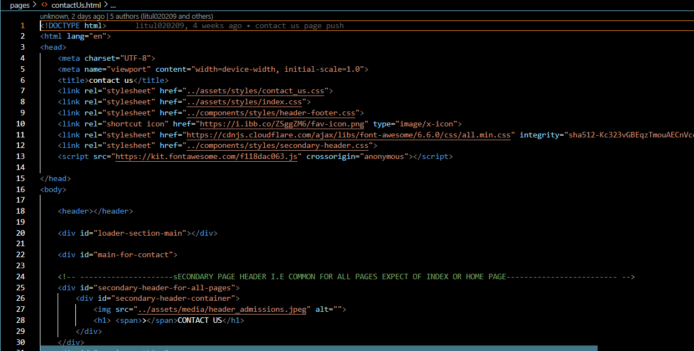 *Fig 1.8*

* **Career Opportunities Module**:
  + List job openings with application requirements and deadlines.
  + 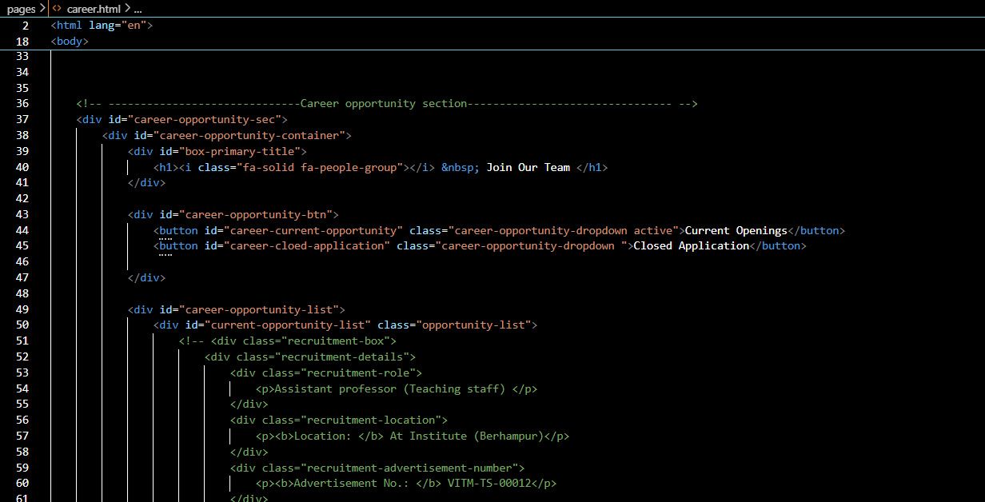Allow candidates to submit job applications and upload resumes.

*Fig 1.9*

* **Fee Management Module**:
* Fetch total fee structure in to a table.
* Search via student Registration Number.
* Pay due payment option will be available.

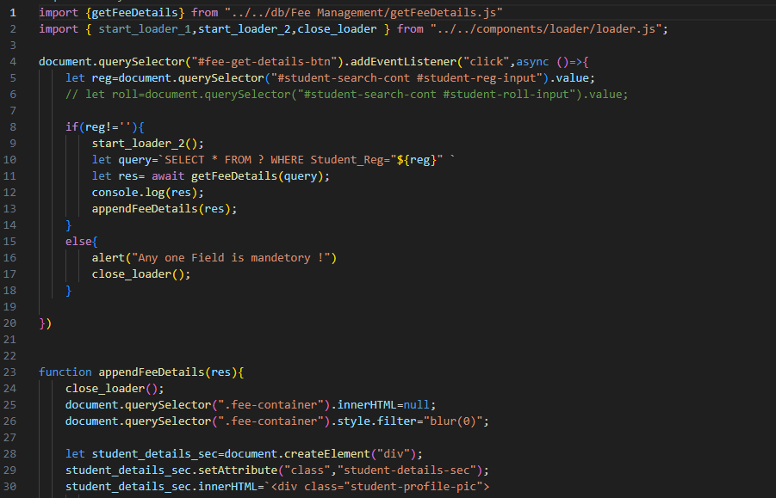

*Fig 2.0*

* **Result Module**:
* Search result via academic year , roll number, registration number, semester and mid-sem.
* Append Result data into a table.

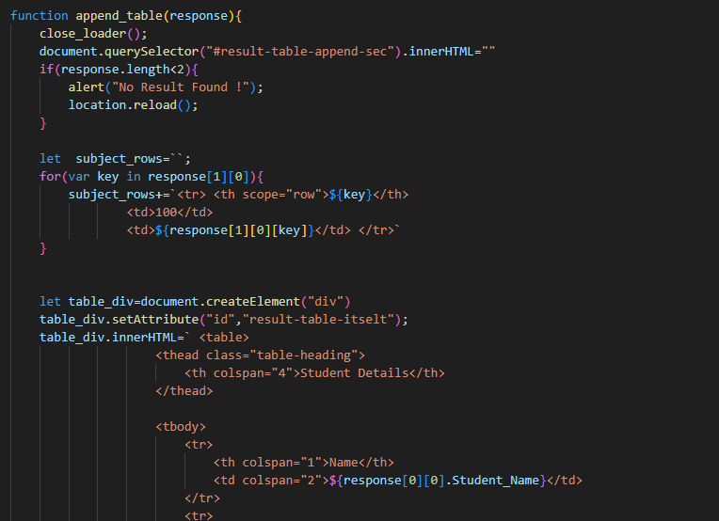

*Fig 2.1*

* **Transportation Module**:
  + Checking Bus route and available buses for today.
  + Track live buses.
  + Check available stopages.

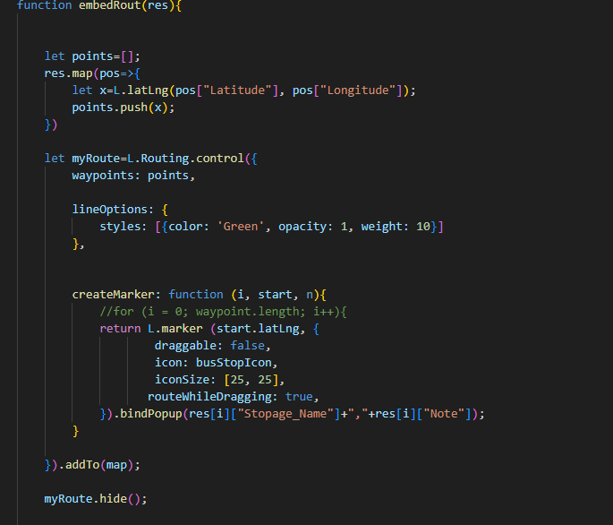

*Fig 2.2*

* **Additional Functional Requirements**:
* **Email OTP Verification**: Verify the applicant's email to enhance application security.
* **Application Form Submission**: Support seamless application submission, document uploads, and confirmation processes.
* **Error Page**: Provide a custom error page to handle navigation issues gracefully.
* **robots.txt File**: Include a robots.txt file to control how search engines crawl and index the site.
* **Non-Functional Requirements**

Non-functional requirements define how the system should perform and include quality attributes, constraints, and usability guidelines:

* **Usability**:
  + The platform should be intuitive, with a clear navigation structure that allows users to locate information within two to three clicks.
  + User-friendly forms, including guidance text and error handling.
* **Performance**:
  + Load times should be under three seconds for all major pages.
  + Backend processing for database queries should minimize delays, especially for high-traffic modules like the Results and Admissions sections.
* **Scalability**:
  + The application must support growth in both the number of users and content without sacrificing performance. This includes a modular design that can support future additions.
* **Security**:
  + Implement secure login mechanisms, role-based access control, and encryption for sensitive data.
  + Use HTTPS protocol for secure communication and follow data protection standards.
* **Compatibility**:
  + The platform should be responsive and compatible with major browsers (Chrome, Firefox, Safari) and mobile devices.
  + Follow WCAG guidelines for accessibility to ensure usability for users with disabilities.

**3.3 Use Cases and User Scenarios for Each Module**

The following use cases and user scenarios outline how the platform functions from the perspective of various users. Each scenario includes key interactions for each major module.

**Use Case 1: Admissions Module**

* **User Scenario**: A prospective student visits the website to learn about the admissions process and apply for a program.
* **Steps**:
  1. The student navigates to the Admissions page and reads about eligibility criteria and deadlines.
  2. They complete an online application form and upload required documents.
  3. The system validates the documents and displays a confirmation message.
  4. An automated email is sent to the student with their application details.

**Use Case 2: Examination and Results Module**

* **User Scenario**: A current student logs in to check their exam schedule and view their results.
* **Steps**:
  1. The student logs in using secure credentials and accesses the Examination section.
  2. They view and download their exam schedule.
  3. After exams, they return to check their results, which are displayed upon entering additional security verification (e.g., date of birth or ID number).

**Use Case 3: Faculty and Staff Directory**

* **User Scenario**: A faculty member updates their profile to include a recent publication.
* **Steps**:
  1. The faculty member logs in and navigates to the profile section.
  2. They update their profile information, adding a new publication.
  3. The update is reviewed by the admin (optional step), then published live on the platform.

**Use Case 4: Events and Announcements Module**

* **User Scenario**: A student checks upcoming events and registers to attend a workshop.
* **Steps**:
  1. The student accesses the Events section and browses upcoming campus events.
  2. They select a workshop and view its details, including date, time, and venue.
  3. The student registers for the event, receiving a confirmation email with event details.

**Use Case 5: Gallery Module**

* **User Scenario**: An admin uploads photos from a recent graduation ceremony to the gallery.
* **Steps**:
  1. The admin logs into the backend and accesses the Gallery module.
  2. They select and upload images, tagging them with event-specific keywords.
  3. The images appear in the gallery, showcasing the ceremony

**Use Case 6: Result Module**

* **User Scenario:**

A student logs into their portal to view their academic results for the current semester.

* **Steps:**

1. The student logs into the student portal with valid credentials.
2. The student navigates to the **Results** or **Academics** section.
3. The system displays available result periods (e.g., Term 1, Term 2, Semester 1).
4. The student selects the desired term or semester.

**Use Case 7: Fee management Module**

* **User Scenario:**

An admin adds fee structures and a student or parent views and pays outstanding fees through the portal.

* **Steps (Student/Parent):**

1. The student or parent logs into the portal.
2. They navigate to the **Fees** section.
3. The system displays the breakdown of due fees, including the amount and due date.
4. The user selects a payment method (online or offline).

**Use Case 7: Transportation Module**

* **User Scenario:**

A parent registers their child for the school transportation service and views assigned routes and timing.

* **Steps:**

1. The parent logs into the parent portal.
2. The parent navigates to the **Transportation** module.
3. They view available bus routes and stops based on their address.
4. The parent selects the appropriate route and registers their child for transportation.

**CHAPTER 4**

**Domain Name Registration**

**4.1 Introduction to Domain Name Registration**

Domain name registration is the process of securing a unique web address for a website, allowing users to easily access it via a memorable and standardized URL rather than an IP address. For the VITM Web Application, securing a domain name is essential for establishing the institute’s online presence and reinforcing its brand identity. A suitable domain name improves accessibility, trust, and credibility, making it easier for students, faculty, staff, and prospective applicants to locate and use the website.

**4.2 Selection of a Domain Name**

For VITM Institute, choosing a domain name involves ensuring that it is:

* Unique and directly related to the institute's name (e.g., "vitm.tech").
* Short and Memorable: The domain should be easy to remember, type, and share.
* Relevant to its audience and brand identity, ideally including "VITM" to make it immediately recognizable**.**

**4.3 Domain Extensions**

The domain extension or TLD (Top-Level Domain) is also a key consideration. Common choices for educational institutions include:

* .edu: Typically reserved for accredited educational institutions, this extension signifies an official educational presence, fostering trust and credibility among users.
* .org: Often used by educational or non-profit organizations. While an option, this extension is less ideal if ".edu" is available.

**4.4 Steps in the Domain Registration Process**

**1. Domain Name Search:** Conducted through a registrar (e.g., GoDaddy, Namecheap, or Google Domains) to ensure that "vitminstitute.edu" is available**.**

**2. Selecting a Registrar:** Reputable domain registrars like Namecheap or Google Domains provide secure registration, DNS management, and privacy protection**.**

**3. Registration and Payment:** The domain is purchased and registered for a specified period, typically 1-5 years, with renewal options.

**4. Configuring DNS Settings:** DNS (Domain Name System) settings are configured to point the domain to the server where the VITM website is hosted. This step links the domain to the application’s IP address**.**

**5. SSL Certificate Installation:** An SSL certificate is added to enable HTTPS, ensuring secure data transmission and enhancing user trust. Many domain registrars offer SSL options, or it can be acquired separately through providers like Let’s Encrypt.

#### ****4.5 Domain Privacy Protection****

Securing the **vitm.tech** domain ensures that VITM Institute has a professional, accessible, and secure online presence that aligns with its mission and vision. By registering a relevant and authoritative domain, VITM effectively positions itself in the digital space, providing an easily recognizable and credible platform for students, faculty, and the community.

**4.6 Benefits of Domain Name Registration for vitm.tech**

Registering a domain name offers several advantages:

* **Professionalism**: A custom domain lends credibility, establishing VITM as a legitimate, professional institution..
* **Brand Recognition**: A consistent online identity helps VITM strengthen its brand and reputation.
* **SEO Benefits**: Search engines often prioritize official domains, which can improve the website's visibility in search results, helping prospective students find VITM more easily.

**CHAPTER-5**

**Technology Stack**

**5.1 Frontend**

1. **HTML (Hyper Text Markup Language)**:

HTML forms the backbone of the website’s structure. It is used for defining the layout, including headers, footers, sections, and other essential content elements.

* + **Justification**: HTML is the standard markup language for web pages, ensuring compatibility across all browsers. Its simplicity and support across different devices make it an ideal choice for building structured content.

*Fig 2.3*

1. **CSS (Cascading Style Sheets)**:

CSS handles the styling of the website, controlling elements like color schemes, fonts, layouts, and spacing. CSS frameworks such as Bootstrap are used to accelerate development by providing pre-built components.

* + **Justification**: CSS enhances the visual appeal and user experience. With Bootstrap, we can ensure responsive design and quicker development due to its library of reusable code components.

*Fig 2.4*

1. **JavaScript**:

JavaScript is used for creating interactive and dynamic features such as form validation, content updates, and animations.

* + **Justification**: JavaScript enables front-end interactivity, making it essential for modern web applications. It allows VITM’s application to offer a dynamic user experience, improving engagement and functionality.



*Fig 2.5*

**5.2 Backend**

1. **Google Appscript**:
   * **Google Apps Script** is a **cloud-based scripting language** developed by Google for light-weight application development in the **Google Workspace platform** (formerly G Suite). It’s based on JavaScript and enables you to automate tasks, build custom add-ons, and integrate with Google services like Gmail, Google Sheets, Docs, Forms, Calendar, and more.



*Fig 2.6*

1. **Google API**:

**Google APIs** are a collection of **programmatic interfaces (APIs)** provided by Google that allow developers to access and interact with a wide range of Google services and data. These APIs can be used to build powerful applications that integrate with products like Gmail, Google Maps, YouTube, Drive, Calendar, and more.

**Key Features:**

* **RESTful Interfaces**: Most Google APIs use REST architecture and return data in JSON format.
* **Authentication via OAuth 2.0**: Secure access using user consent and authorization tokens.
* **Scalable and Cloud-Based**: Built to work at global scale via Google Cloud Platform

**5.3 Database**

1. **MySQL**:

A relational database management system, MySQL is widely used for applications that require structured data storage and complex queries.

* + 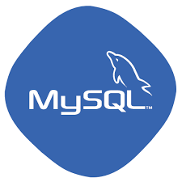**Justification**: MySQL is reliable and scalable, making it suitable for handling large datasets, such as student records and admissions data. Its ACID compliance ensures data integrity and security.

*Fig 2.7*

**5.4 Other Tools**

1. **Version Control (Git)**:

* **Purpose**: Git is a distributed version control system.
* **Justification**: It allows developers to track changes in their codebase, collaborate with others, and maintain different branches of development. Git is essential for maintaining a clean code history and for reverting to previous versions when necessary.



***Fig 2.8***

1. **GitHub**:

* **Purpose**: GitHub is a platform that hosts Git repositories and provides collaboration tools.
* **Justification**: Beyond just hosting code, GitHub offers powerful tools for code reviews, issue tracking, and project management, making it easier for teams to work together on the same project. It also facilitates open-source contributions and sharing of code across organizations.



*Fig 2.9*

1. **Postman**:

* **Purpose**: Postman is a tool for testing and developing APIs.
* **Justification**: It provides a user-friendly interface for creating, testing, and documenting APIs. Developers can simulate API requests and test responses to ensure functionality. Postman is essential for backend developers and QA teams to validate that APIs are working as expected before releasing them to production.

*Fig 3.0*

1. **Fire Base** (if you mean Adobe Firefly):

* **Purpose**: Adobe Firefly is a suite of AI-powered tools for generating images, text effects, and other creative assets.
* **Justification**: Firefly is useful for designers, marketers, and content creators who need to quickly generate unique visuals or assets. It speeds up creative workflows, particularly when producing variations of designs or visuals, making it valuable for rapid prototyping and content creation.



*Fig 3.1*

**5.5 Justification for Technology Choices**

Each technology in the stack was chosen for its benefits in **scalability**, **performance**, and **security**:

* **Scalability**: The combination of Node.js and React, or PHP and MySQL, ensures that the application can handle increased user load as the institution grows.
* **Performance**: Asynchronous processing in Node.js, combined with MySQL’s query optimization, ensures quick data access and low latency.
* **Security**: Using secure frameworks with role-based access and encryption ensures the privacy of user data and compliance with data protection standards.

**CHAPTER-6**

**System Design**

**6.1 System Architecture**

The system follows a **client-server architecture** where the frontend interacts with the backend through API calls. This model divides responsibilities between the user interface (frontend) and data processing (backend) to ensure optimal performance.

* **Data Flow**

1. **User Request**: Users access the website and interact with the frontend components.
2. **API Request**: When the user submits information (e.g., login credentials, admission form), the frontend sends an API request to the backend server.
3. **Data Processing**: The backend server validates the request, processes data, and interacts with the database to fetch or store data as needed.
4. **Response**: Processed data or error messages are returned to the frontend for display to the user.

* **Control Flow**
* **Frontend Control**: Manages user interactions and sends appropriate requests to the backend based on user actions.
* **Backend Control**: Verifies, processes, and routes requests based on user roles and permissions, ensuring secure access to protected resources.

**6.2 Microservices or Modular Design**

The application follows a **modular design**, where each module (Admissions, Results, Events) functions as a semi-independent unit. This structure makes the application easier to maintain and scale

* **Module Details**

**1. Home Page**

* **Components**: Header, quick links, featured announcements, and events preview.
* 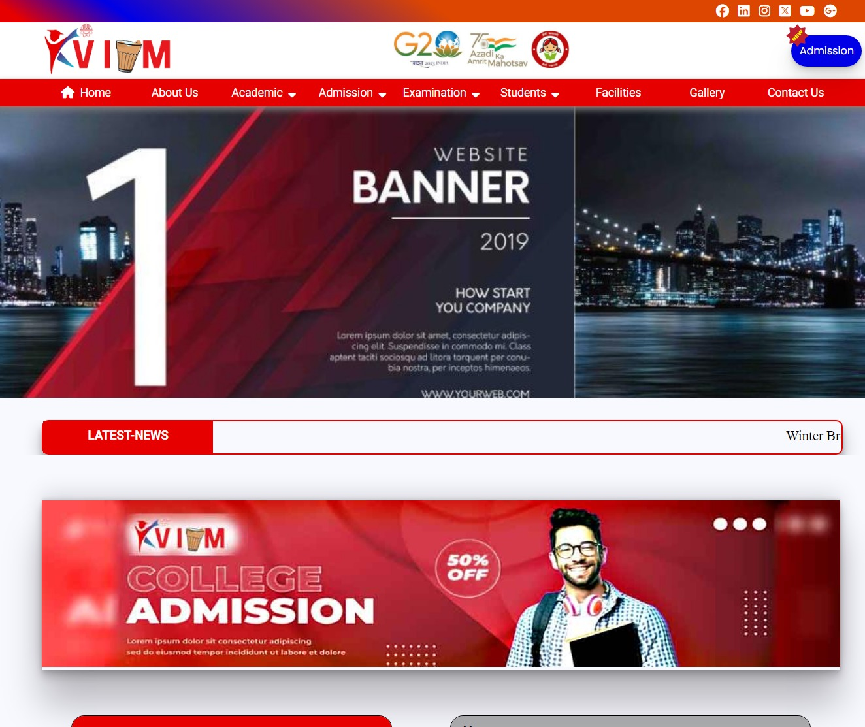**User Interactions**: Links to key modules, search functionality, and an option to log in.

*Fig 3.2*

**2. Facilities**

* **Structure**: Information on campus facilities like libraries, labs, and sports facilities.
* 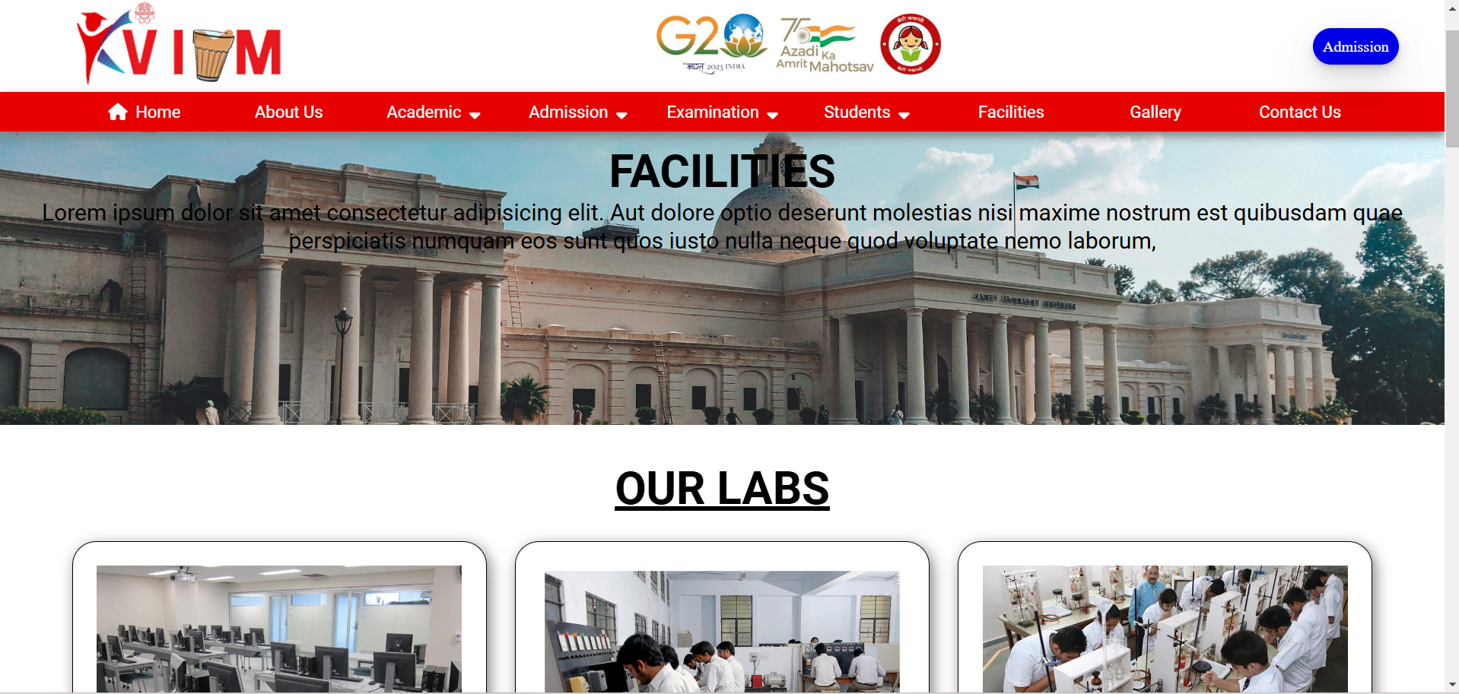**User Interactions**: Visitors can view facilities and related images, filtering by type.

*Fig 3.3*

**3. Gallery**

* **Design**: Grid layout to display campus images and event photos.
* 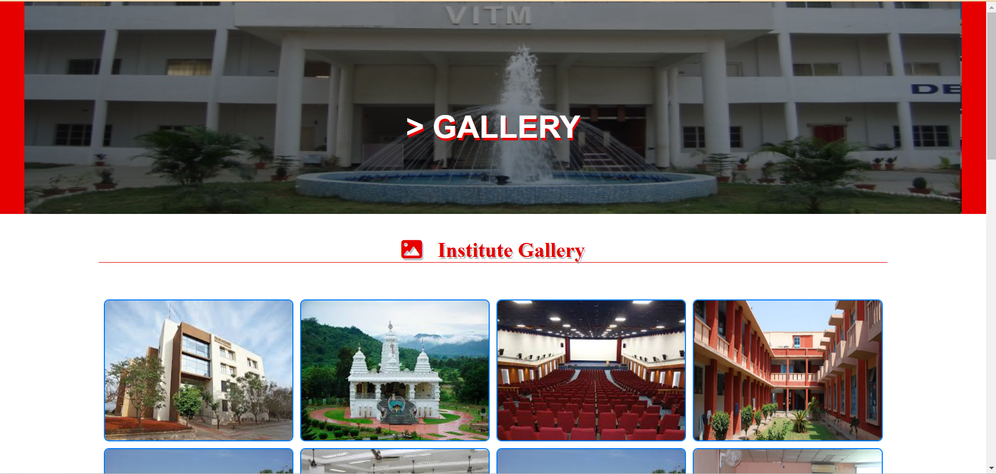**Management**: Admin access to upload/delete images, tagging options for easy navigation.

*Fig 3.4*

**4. Examinations**

* **Interface**: Schedule overview, downloadable schedule, results section.
* 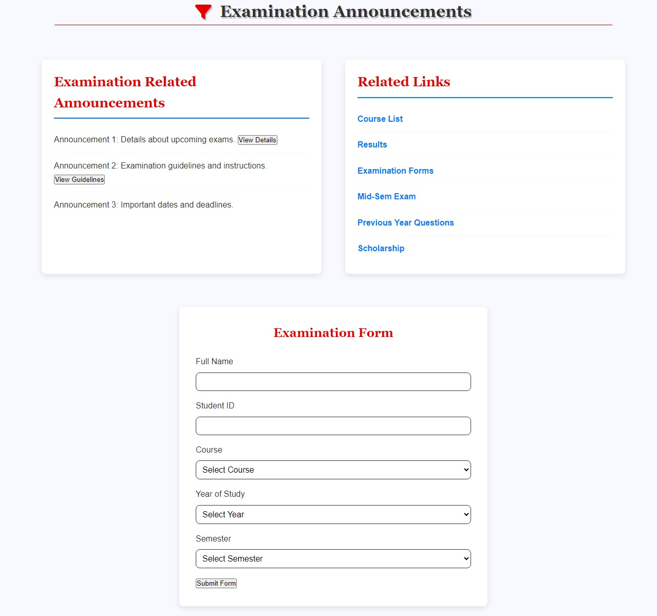**User Actions**: Login required for students to view results securely

*Fig 3.5*

**5. Staff & Faculty**

* **Profile Listings**: Searchable list of staff with detailed profiles.
* 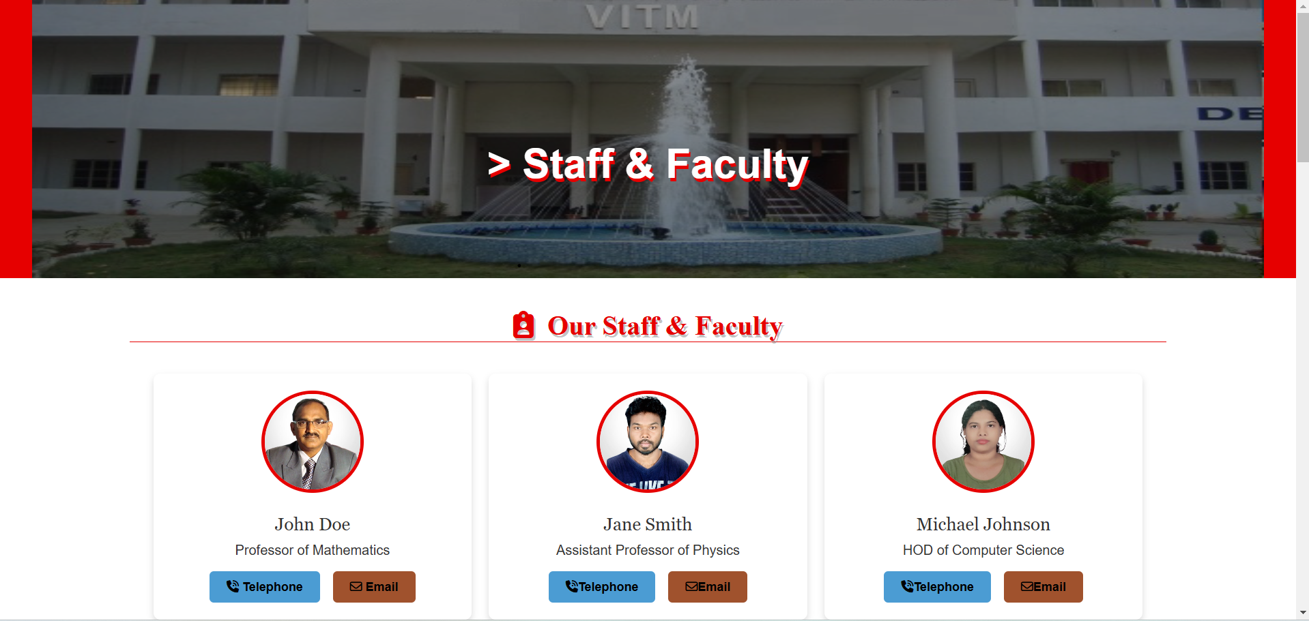**Interactivity**: Search by department, name, or designation

*Fig 3.6*

**6. Admission**

* **Application Form**: Structured form for prospective students.
* 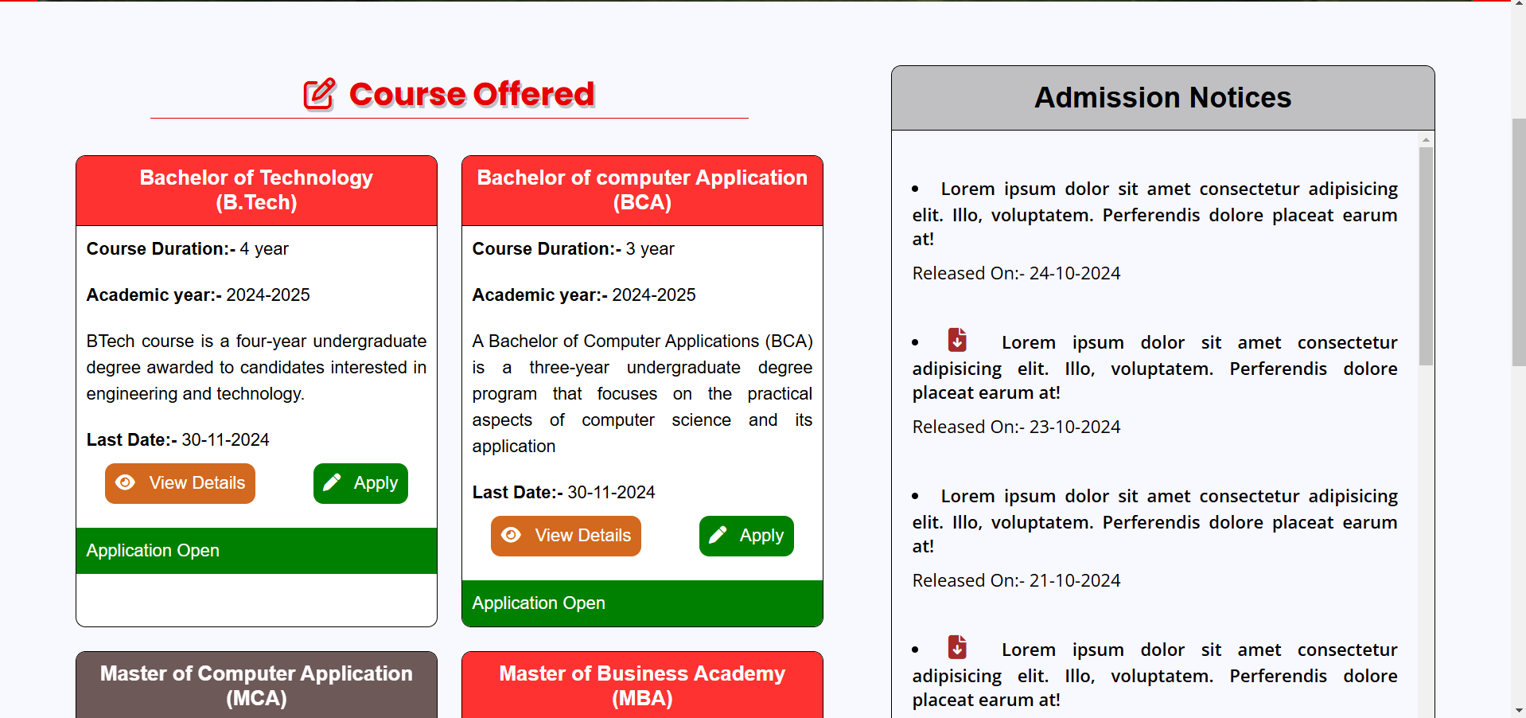**Document Upload**: Supports secure document uploads for eligibility verification.

*Fig 3.7*

**7. Syllabus**

* **Course Structure**: Downloadable syllabi organized by department.
* 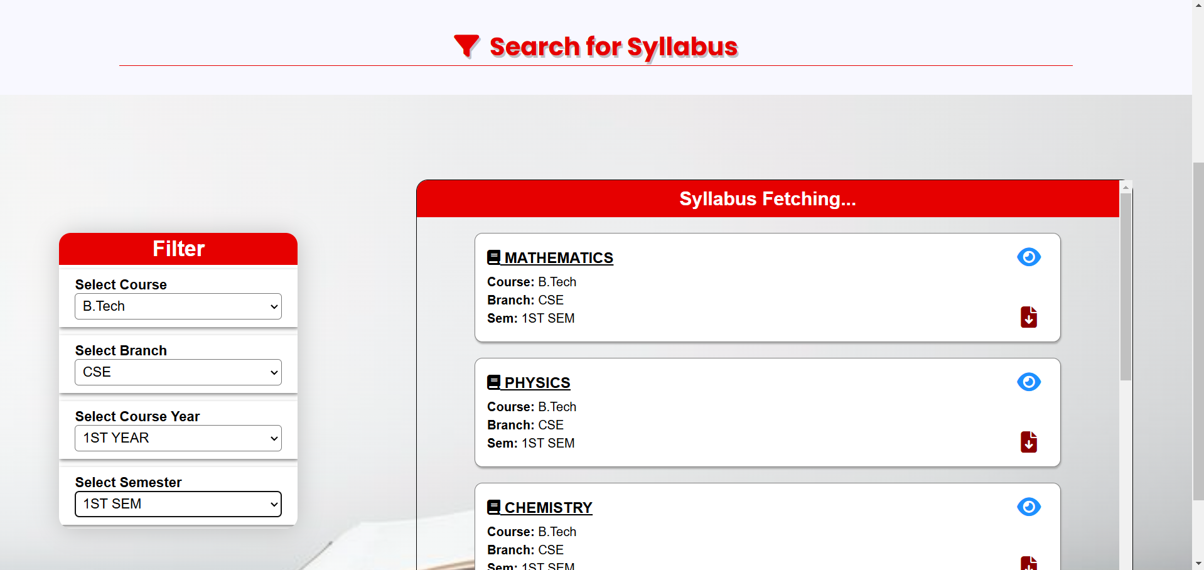**User Access**: Accessible for students and faculty members.

*Fig 3.8*

**8. Result**

* **Portal Design**: Secure login and result retrieval by entering specific identifiers.
* 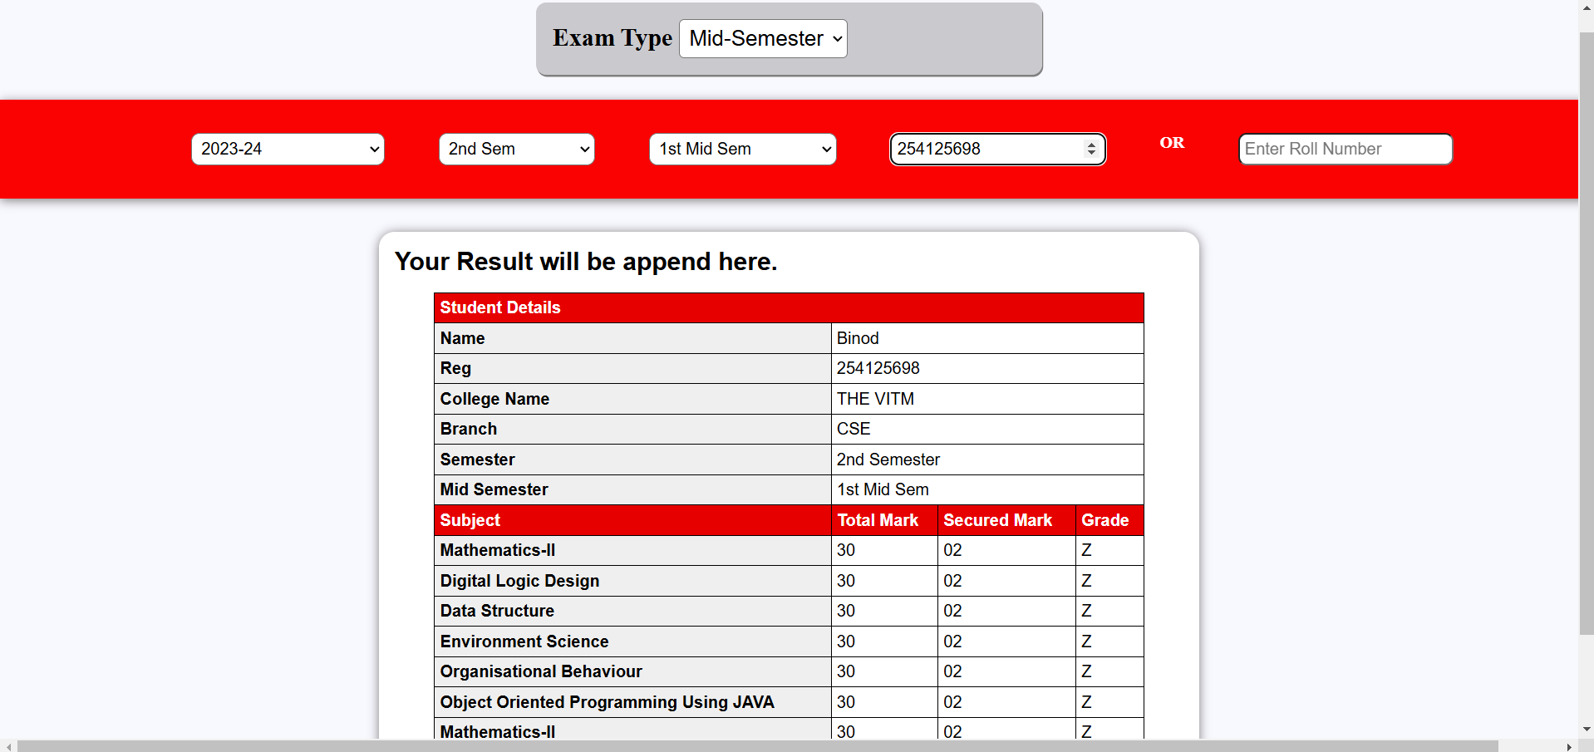**Data Privacy**: Ensures only authorized access to sensitive information.

*Fig 3.9*

**9. Announcement**

* **Updates**: Real-time notifications for important announcements.
* 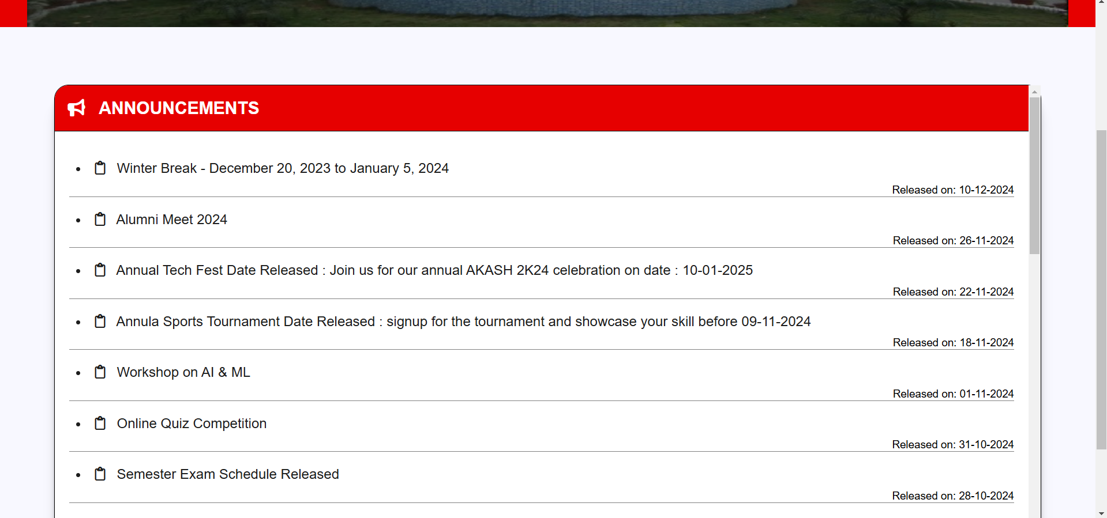**Filter**: Filter by academic, non-academic, or event-related updates.

*Fig 4.0*

**10. Events**

* **Calendar View**: Display upcoming events with an RSVP option.
* 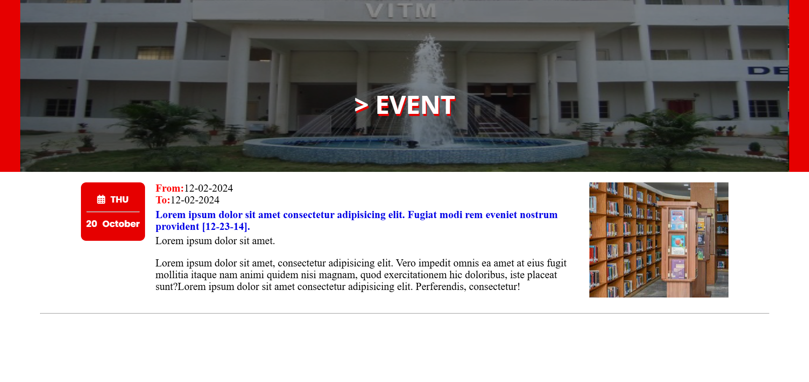**Details**: Venue, date, and registration option for relevant events.

***Fig 4.1***

**11. About Us**

* **Content**: History, mission, vision, and founder details.
* 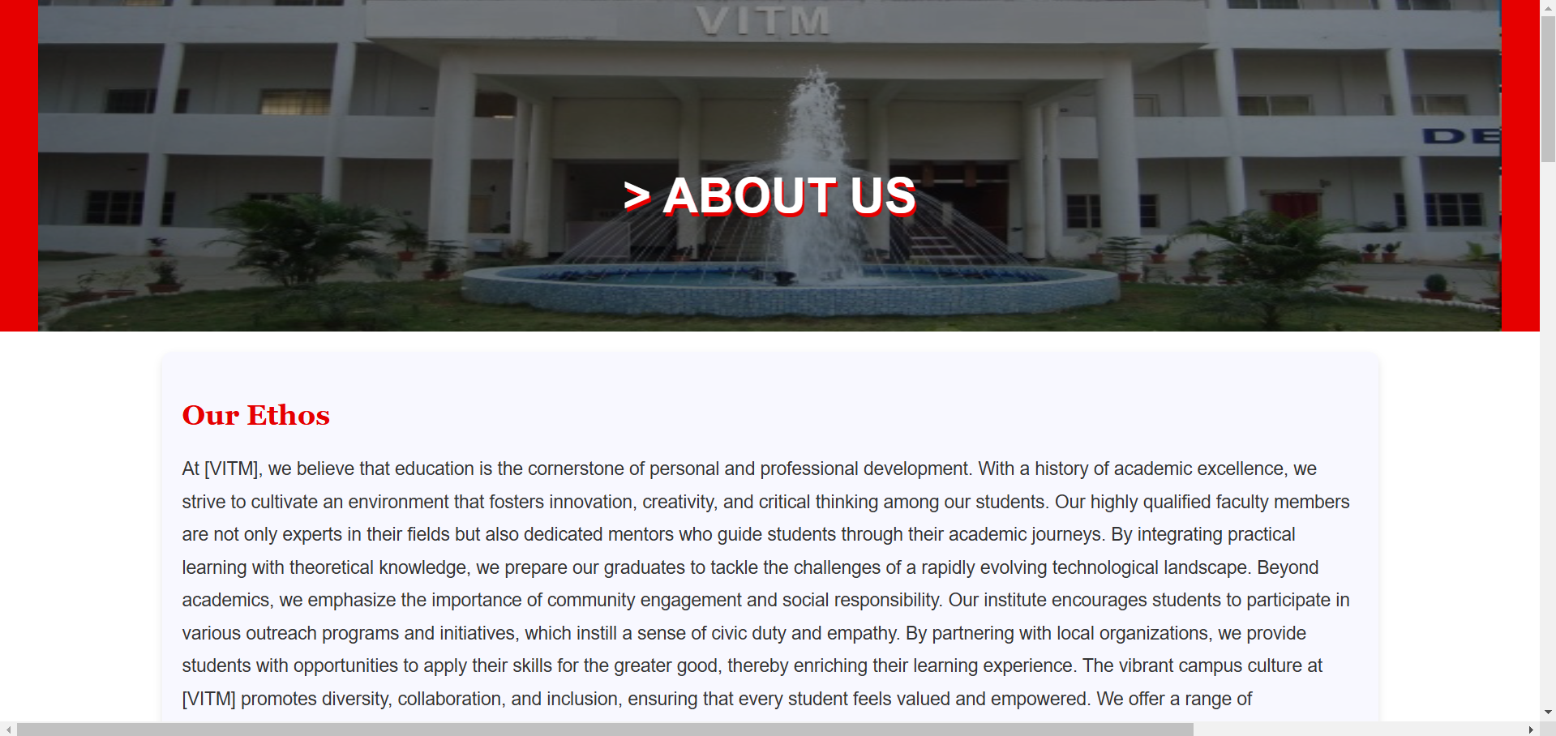**Visuals**: Integrated with a timeline to showcase institutional milestones.

*Fig 4.2*

**12. Contact Us**

* **Form**: Inquiry form with Google Maps integration.
* 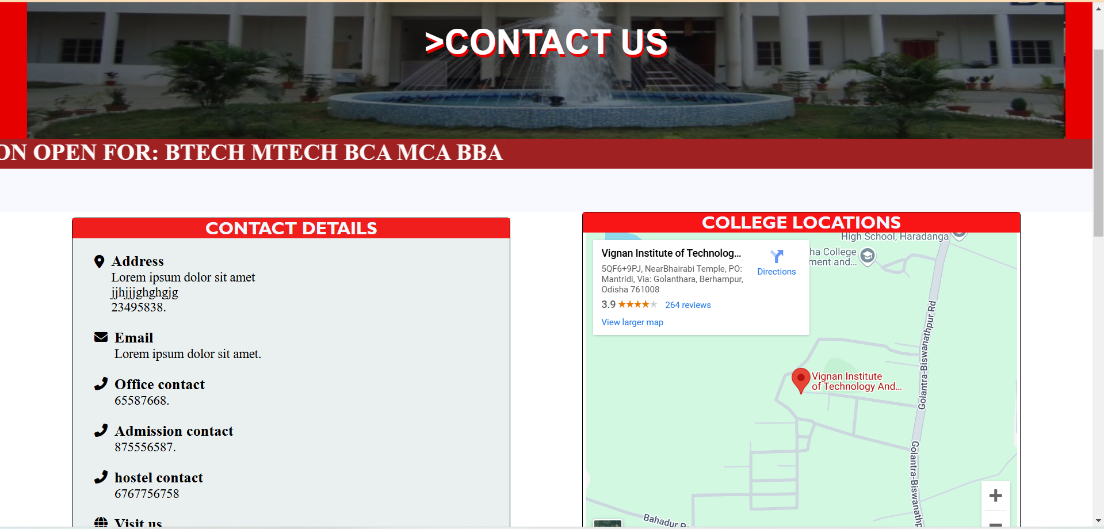**Contact Details**: Email, phone, and social media links.

*Fig 4.3*

**13. Career**

* **Job Listings**: Open positions with application deadlines.
* 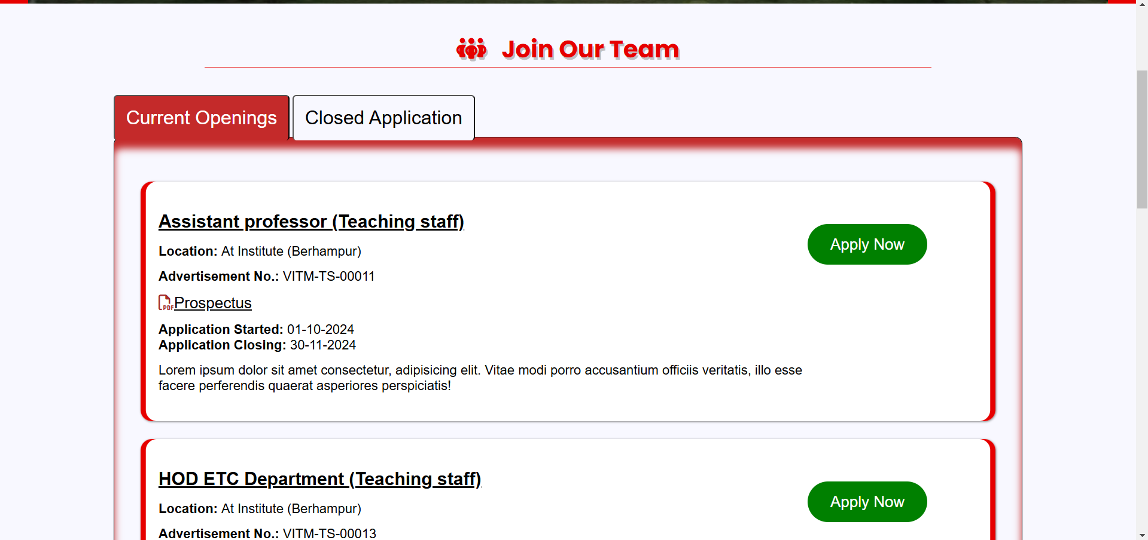**Submission**: Secure form for job application and resume upload.

*Fig 4.4*

**14. Fee Management**

* **Search:** Search Student fee details by registration number.
* **Pay Fee:** Button to to pay online the due fee.

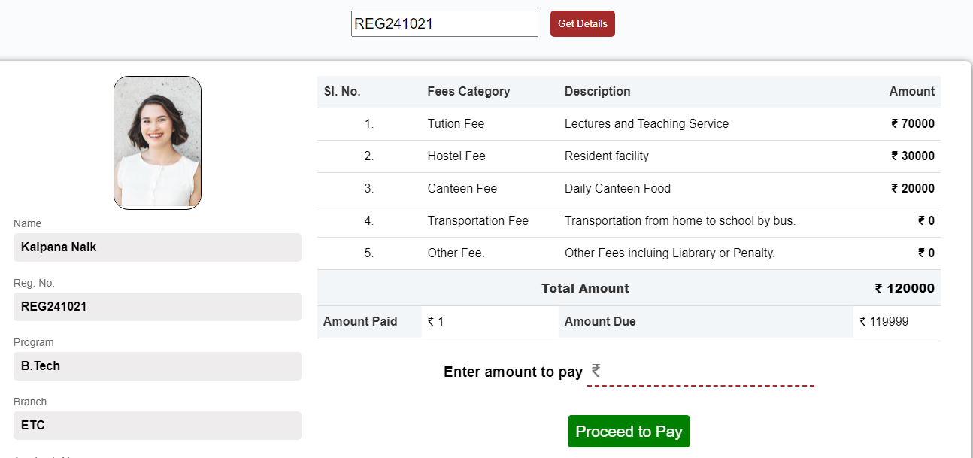

*Fig 4.5*

**15. Transportation Management**

* **Check Route:** Checking for today’s active route and buses.
* **Track Bus:** Check for bus route and stoppages on embedded map (Street view)

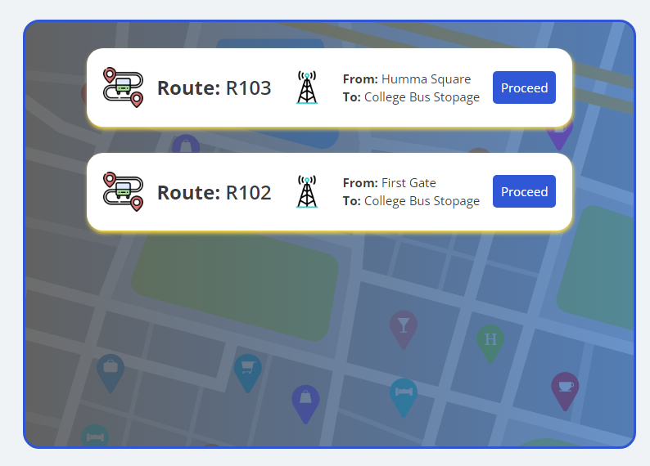

*Fig 4.6*

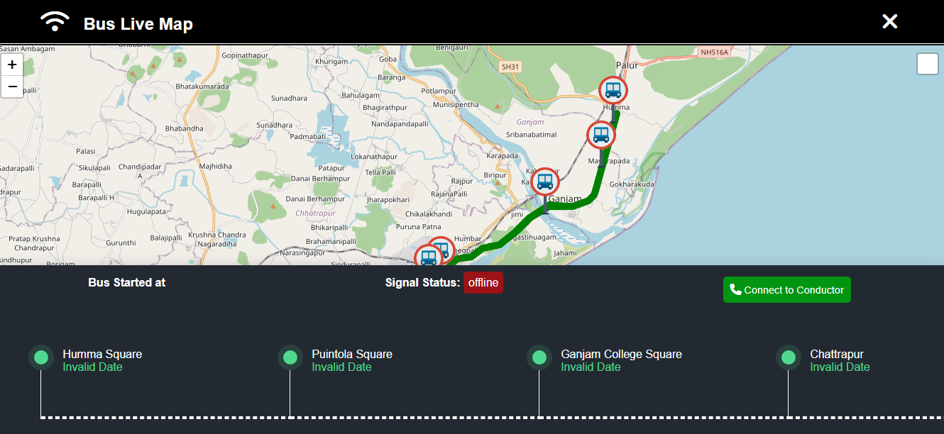

*Fig 4.7*

**14.Additional Modules and Functionalities**

* 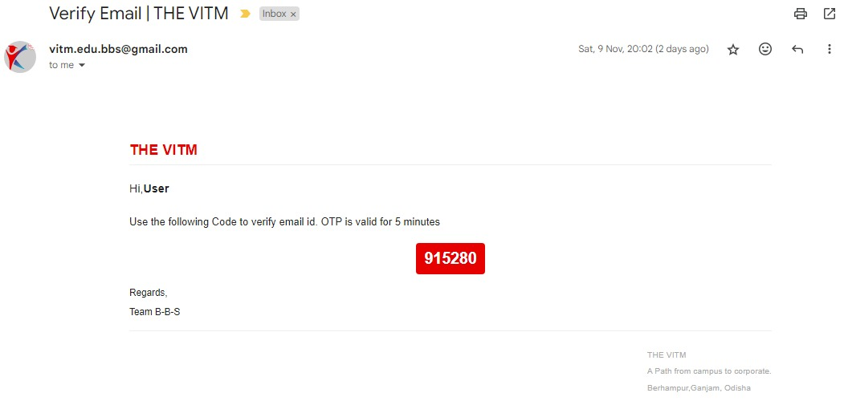**Email OTP Verification**: Verify the applicant's email to enhance application security.

*Fig 4.8*

* **Application Form Submission**: Supports seamless submission of admissions and job applications.
* **Error Page**: Custom error page to handle user navigation errors smoothly.
* **robots.txt File**: Configured robots.txt file to control search engine crawling and indexing.

**6.3 User Interface Design**

**1. Wireframes and Mockups**

To create a user-friendly experience, wireframes and mockups were developed for major pages. The wireframes are structured to maintain clarity and flow, ensuring ease of navigation and visual appeal.

The primary layouts include:

* **Homepage**: Featuring a top navigation bar with links to key sections (Admissions, Announcements, Contact Us). It has a hero banner showcasing key messages, quick links, recent updates, and featured events.
* **Admissions Page**: Includes step-by-step application instructions, a downloadable brochure, and a clear, organized application form.
* **Student Portal (Examinations and Results)**: Provides an easy login area with a secure, accessible dashboard for viewing grades, schedules, and notifications.
* **Gallery**: Displays images in a grid format with filters to sort by event type or date.

**2. User Experience (UX) Considerations**

The UX design aims to be intuitive and straightforward, prioritizing accessibility and usability for all users:

* **Clear Navigation**: Simple, well-structured menus and breadcrumb trails for better user orientation.
* **Consistency**: Consistent design across pages with predictable layouts, making navigation easy for new and returning users.
* **Responsive Design**: Ensures compatibility across various devices and screen sizes to accommodate all users.
* **Error Handling**: Clear error messages and form validations, especially in modules like Admissions and Contact Us, to guide users through the process.

**3.Color Scheme, Typography, and Branding**

* **Color Scheme**: The color palette reflects VITM’s branding, using neutral tones for backgrounds with primary and secondary colors for headings, call-to-action buttons, and highlights.
* **Typography**: Readable font styles such as Arial or Roboto, ensuring accessibility and uniformity across content.
* **Branding Consistency**: The logo, institutional colors, and fonts are consistent across the application to strengthen brand identity.

**6.4 Database Design**

**1. Entity-Relationship (ER) Diagram**

The ER Diagram defines the relationships between entities, focusing on the main modules like **Students, Faculty, Courses, Events, Admissions, and Results**. Key relationships include:

* **Student–Enrollment–Course**: Students enroll in multiple courses, and each course is associated with multiple students.
* **Faculty–Teaches–Course**: Faculty members teach courses, and each course has a primary instructor.
* **Student–Exam–Result**: Exam results are tied to individual students and exams, with data on scores and performance.

**2. Database Tables and Structures**

Key tables in the database schema include:

* **Student Table**: Stores student IDs, names, contact info, course enrollments, and login credentials.
* **Faculty Table**: Contains faculty details like department, specialization, and contact info.
* **Course Table**: Lists courses, including course IDs, names, syllabi, and schedules.
* **Exam Table**: Defines exams, with date, type, and related course information.
* **Results Table**: Links students to exams, storing grades and other academic details.

**3.Database Normalization and Indexing**

The database design follows **third normal form (3NF)** to eliminate data redundancy:

* **Normalization**: Reduces duplication by separating data into related tables (e.g., separating contact details from the main student information).
* **Indexing**: frequently queried columns, such as student_id, exam_id, and course_id, are indexed to improve retrieval speed.

**CHAPTER-7**

**System Development**

**7.1 Backend Development**

**1. Backend Architecture and API Design**

The backend follows a **RESTful API architecture**, providing endpoints for each major module. The architecture is designed with a **modular approach**, where each module (e.g., Admissions, Events, Results) has its own set of APIs.

**Key API Endpoints:**

* **Admissions**:
  + GET /admissions/info: Fetches information on eligibility and criteria.
  + POST /admissions/apply: Submits an application form and uploads documents.
* **Exams and Results**:
  + GET /exams/schedule: Retrieves the examination schedule based on the user’s course.
  + POST /results/view: Securely fetches a student’s result after verification.
* **Events and Announcements**:
  + GET /events/upcoming: Lists upcoming events.
  + POST /announcements/create: Admin endpoint for creating new announcements.

**2.Authentication and Session Management**

* **Authentication**: Implemented using **JWT (JSON Web Tokens)** for secure and stateless user authentication. JWT tokens are generated upon login and stored securely, allowing authorized access to private endpoints.
* **Session Management**: Sessions expire after a set duration to ensure security, requiring users to re-authenticate after inactivity.

**3. Data Processing and Error Handling**

The backend handles complex data queries and ensures robust error handling:

* **Data Processing**: Data is sanitized before database interactions to prevent SQL injection.
* **Error Handling**: Standardized error responses guide users on corrective actions for input errors or failed operations.

**7.2 Frontend Development**

**1. Responsive and Accessible UI Development**

The frontend is designed to be responsive and fully accessible:

* **Responsive Design**: Built with CSS Flexbox and Grid for a layout that adjusts to screen sizes.
* **Accessible Components**: Screen reader-friendly labels, high-contrast colors, and keyboard navigation ensure that the platform meets accessibility standards.

**2. Frontend Components and Integration with Backend**

Each module has dedicated components that interact with backend APIs:

1. **Admissions Form**: A multi-step form that submits data to the backend and validates user inputs.
2. **Exam Schedule**: Displays the schedule based on real-time data retrieved from the API.
3. **Events Calendar**: Fetches and displays upcoming events in a calendar format.

**3. Handling Form Submissions, User Interactions, and Dynamic Content**

Forms and content updates are handled with JavaScript for interactivity:

* **AJAX Requests**: Form submissions and data updates are handled asynchronously to avoid page reloads.
* **Dynamic Updates**: JavaScript dynamically updates sections like announcements, making user interactions seamless.

**CHAPTER-8**

**Database Management**

This chapter focuses on the design, implementation, and management of the database system that supports the various modules within the application. The database system is central to ensuring that data is stored, retrieved, and managed efficiently across all modules.

**8.1 Database Design**

1. **Database Type**: The application uses a relational database management system (RDBMS) for structured data management. This type of database is suitable for managing the structured, interconnected data required by the application modules (e.g., Admissions, Faculty Directory).
2. **Entity-Relationship (ER) Diagram**: An ER diagram illustrates the relationships between core entities such as Students, Faculty, Courses, Events, and Applications. Key relationships are designed to maintain referential integrity and optimize data retrieval.
3. **Core Tables and Relationships**:
   * **Students**: Stores student profiles, including personal information, academic status, and login credentials.
   * **Admissions**: Stores application data, including applicant information, document uploads, and application status.
   * **Faculty**: Manages faculty profiles, qualifications, and contact details.
   * **Courses and Syllabus**: Details of courses offered, syllabus documents, and course schedules.
   * **Examinations and Results**: Records examination schedules, results, and access permissions for students.
   * **Events**: Stores event details, including date, venue, RSVP requirements, and registrations.
   * **Career Opportunities**: Maintains job listings and submitted applications from candidates.
   * **Result:** Fetch Mid-Sem Result form Student result table.
   * **Fee page:** Getting Student fees details from students database via API , and align data to an table.
   * **Transportation :** Get live location of bus from conductor portal in every milliseconds and show it on public portal.

**8.2 Database Schema**

The database schema outlines the structure of the tables and their relationships:

1. **Students Table**
   * **Columns**: StudentID, Name, Email, Department, Program, Year, LoginCredentials, etc.
   * **Primary Key**: StudentID
   * **Relationships**: Linked to the Admissions, Results, and Courses tables.
2. **Admissions Table**
   * **Columns**: ApplicationID, StudentID (foreign key), Status, SubmittedDocuments, DateSubmitted, etc.
   * **Primary Key**: ApplicationID
   * **Relationships**: Linked to Students table through StudentID.
3. **Faculty Table**
   * **Columns**: FacultyID, Name, Department, Designation, ContactInfo, ProfileDetails.
   * **Primary Key**: FacultyID
4. **Courses Table**
   * **Columns**: CourseID, DepartmentID, Title, Description, SyllabusLink.
   * **Primary Key**: CourseID
   * **Relationships**: Linked to Faculty and Students tables.
5. **Examinations Table**
   * **Columns**: ExamID, CourseID, Date, Location, ResultsLink.
   * **Primary Key**: ExamID
   * **Relationships**: Linked to Courses and Students tables.
6. **Results Table**
   * **Columns**: ResultID, StudentID (foreign key), ExamID (foreign key), Grade.
   * **Primary Key**: ResultID
   * **Relationships**: Linked to Students and Examinations tables.
7. **Events Table**
   * **Columns**: EventID, Title, Description, Date, Venue, RSVPOptions.
   * **Primary Key**: EventID
8. **Career Opportunities Table**
   * **Columns**: JobID, Title, Department, Requirements, Deadline, ApplicantID (foreign key).
   * **Primary Key**: JobID
   * **Relationships**: Linked to Students and Applications tables.

**8.3 Data Integrity and Constraints**

To ensure data consistency and accuracy:

* **Primary Keys and Foreign Keys**: Define primary and foreign key constraints to maintain relationships between tables.
* **Not Null Constraints**: Apply to critical fields (e.g., student names, contact info) to prevent null entries.
* **Check Constraints**: Enforce valid values (e.g., only valid grades in the Results table).
* **Unique Constraints**: Ensure unique entries (e.g., unique emails for Students and Faculty).

**8.4 Data Access and Management**

1. **CRUD Operations**: The database supports CRUD (Create, Read, Update, Delete) operations for all tables, allowing the application to manage data effectively.
2. **Stored Procedures and Views**:
   * **Stored Procedures**: Used to perform complex queries for modules like Admissions and Results, where multiple tables are involved.
   * **Views**: Simplify data retrieval for specific user roles (e.g., faculty-only view of students in their courses).
3. **Indexing**: Indexes are applied to frequently queried columns (e.g., StudentID, CourseID) to improve data retrieval speed.

**8.5 Database Backup and Recovery**

1. **Backup Strategy**: Daily backups are scheduled to prevent data loss.
2. **Recovery Plan**: Includes procedures for data restoration from backups and disaster recovery in case of data corruption or hardware failure.

**8.6 Security and Compliance**

1. **Access Control**: Role-based access control ensures that users can only access data relevant to their roles (e.g., student, faculty, admin).
2. **Data Encryption**: Sensitive information (e.g., login credentials, grades) is encrypted in the database.
3. **Audit Trails**: Logs track critical actions like login attempts, data updates, and administrative actions.
4. **Compliance**: The database follows data privacy regulations (e.g., GDPR) for handling personal data.

**CHAPTER-9**

**Testing and Quality Assurance**

**1. Testing Methodologies**

To ensure the VITM Web Application performs reliably, multiple testing methodologies are used throughout the development process:

* **Unit Testing**: Each component, function, and API endpoint is tested individually to confirm that it performs its specific task correctly. Unit tests are written for both frontend and backend functions.
* **Integration Testing**: Tests how different modules interact within the system, ensuring seamless data flow between components. For instance, the Admissions form is tested to confirm correct integration with the backend to store applicant data.
* **System Testing**: The entire application is tested in an environment that simulates real-world usage. This includes navigation across the application’s pages, data retrieval, and login verification to confirm that all features work as expected.

**2. Manual vs. Automated Testing**

* **Manual Testing**: Performed for aspects where human insight is essential, such as user experience and visual design checks. Manual testing is also applied to verify non-functional requirements like UI consistency and responsive layout.
* **Automated Testing**: Key functional requirements and repetitive tests, such as form validations and login procedures, are automated using testing tools like Selenium and Jest for frontend and backend functions. Automation ensures that these functions work as expected after every code update, saving time in the long term.

**3. User Acceptance Testing (UAT) and Feedback Loop**

UAT is conducted with a select group of end-users, including students, faculty, and administrators, who evaluate the application for usability and functionality:

* **User Feedback**: Users provide insights on ease of navigation, clarity of content.
* **Feedback Loop**: Adjustments are made based on user feedback to refine user experience, such as improving navigation menus or adding help text where users face difficulties.

1. **Manual Testing**  
    Manual testing, performed by test engineers, is an essential approach to identify issues that might not be detected by automation alone. This involves:

* **Designing Test Cases**: Test engineers create detailed test cases based on the application's requirements, which outline specific steps to follow and expected outcomes.
* **Executing Tests Manually**: Engineers perform tests without automation tools, exploring the application as a user would, interacting with different functionalities, and looking for any unexpected behavior.

**CHAPTER-10**

**Deployment Strategy**

**1. Deployment Environment**

The deployment environment is designed for scalability and ease of access:

* **Cloud Hosting**: The application is hosted on a reliable cloud provider **Vercel App** that ensures high availability and fast performance.
* **Load Balancer**: A load balancer distributes incoming traffic across multiple servers to optimize application performance and minimize latency.

**2. Deployment Process using CI/CD Pipelines**

To streamline updates and bug fixes, a Continuous Integration and Continuous Deployment (CI/CD) pipeline is set up:

* **Version Control Integration**: Using GitHub or GitLab, every code change is tracked and merged into the main branch through pull requests. This ensures code stability and compatibility.
* **Continuous Integration (CI)**: Automated testing is triggered for every code commit, reducing errors before deployment.
* **Continuous Deployment (CD)**: Once tests pass, the updated code is automatically deployed to the staging environment. Following approval, it is deployed to production, ensuring that the latest features and fixes are always live.

**3. Server Configuration, Domain Setup, and SSL Certificate Installation**

* **Server Configuration**: The server is optimized for performance with configurations for caching, compression, and load balancing.
* **Domain Setup**: A custom domain is purchased and configured to direct users to the VITM Web Application.
* **SSL Certificate Installation**: SSL certificates are installed to ensure data encryption and secure HTTPS connections, providing a secure environment for all users.

**CHAPTER-11**

**Security Considerations**

**1. User Authentication and Data Encryption**

* **User Authentication**: Role-based access control (RBAC) is implemented, allowing different permissions for students, faculty, and administrators. Multi-factor authentication (MFA) is also considered for administrative access to enhance security.
* **Data Encryption**: Sensitive data, such as login credentials and personal details, is encrypted using SSL/TLS. Passwords are stored in hashed form in the database to prevent unauthorized access.

**2. Measures Against Common Security Threats**

To protect against common threats, the application includes various security measures:

* **SQL Injection Protection**: The application uses parameterized queries and input validation to prevent SQL injection attacks.
* **Cross-Site Scripting (XSS) Prevention**: All user input is sanitized before displaying on the website, preventing malicious scripts from being injected.
* **Cross-Site Request Forgery (CSRF) Protection**: CSRF tokens are embedded in forms, ensuring that data submissions are verified and originate from authorized users only.

**3. Compliance with Data Protection Regulations**

The application is designed to comply with data protection regulations such as the **General Data Protection Regulation (GDPR)**:

* **User Consent and Data Privacy**: Explicit consent is obtained for data collection, with an opt-in/opt-out mechanism for certain types of information sharing.
* **Data Retention Policies**: Sensitive data, such as personal identification information, is stored only as long as necessary, and users have the right to request data deletion.

**CHAPTER 12**

**Total Cost Estimation**

**12.1 Overview**

This section gives an estimate of the costs for setting up and maintaining the VITM Web Application, Version 2.0. It includes one-time setup costs and any yearly fees to keep the application running smoothly.

**12.2 Breakdown of Costs**

1. **Domain Registration and SSL Certificate**
   * Domain: Registering a domain name usually costs 139 rupees per year.
   * SSL Certificate: Many hosting providers offer free SSL certificates, but if needed, a basic paid SSL costs about $50-100 per year.
   * Total: ₹ 139 rupees per year.
2. **Web Hosting**
   * Free Hosting Options: **Vercel App** provide free hosting but may have limited storage or features.
   * Total: Free to ₹ 0 per year.
3. **Development Costs**
   * Using Free Tools and Platforms: If using in-house resources or student developers, development costs can be minimized.
   * DIY Platforms: Platforms like WordPress or Wix offer free templates and design tools that make it easy to create web applications with little to no coding.
   * Total: Free or minimal if using free tools and resources.
4. **Software and Licensing**
   * Project Management Tools: Free options include Trello or Asana for tracking tasks.
   * Version Control: GitHub offers free repositories and collaboration tools.
   * Total: Free.
5. **Testing and Quality Assurance**
   * Free Testing Tools: Tools like Selenium (for automated testing) are free to use.
   * User Testing: Testing can be done internally with students or staff for feedback.
   * Total: Free.
6. **Maintenance and Support**
   * Free Support: Ongoing maintenance can be handled by internal IT staff or volunteers.
   * Updates: Free updates can be done as needed if using open-source platforms or free tools.
   * Total: Free if managed in-house.

**CHAPTER-13**

**Maintenance and Future Scope**

**13.1 Maintenance Plan**

An ongoing maintenance plan is established to ensure the application remains functional, secure, and relevant:

* **Regular Updates**: Scheduled updates for security patches, bug fixes, and feature improvements are deployed to keep the application up-to-date.
* **Performance Monitoring**: Automated monitoring tools track application performance metrics like load time, response time, and server health, allowing for proactive adjustments.
* **User Support and Issue Tracking**: A support system with issue tracking (e.g., Jira) is set up to log and resolve user-reported issues. This ensures that problems are addressed quickly, improving user satisfaction.

**13.2 Potential Future Features**

Several potential features have been identified for future versions of the application to expand functionality and enhance user experience:

* **Mobile Application**: A dedicated mobile app for iOS and Android, providing on-the-go access to features like results, notifications, and event updates.
* **AI-Based Chatbot for Student Assistance**: An AI chatbot could assist users with frequently asked questions, navigation guidance, and troubleshooting, available 24/7 for enhanced user support.
* **Analytics Dashboard for Administrators**: An admin dashboard with insights into user engagement and data trends, helping the institution make data-driven decisions to improve services.

**13.3 Recommendations for Scalability**

As the institution grows, the application should be ready to scale:

* **Horizontal Scaling**: Adding more servers as user demand increases to maintain performance.
* **Database Optimization**: Consider migrating to a distributed database or using sharding to handle large datasets more efficiently.

**CHAPTER-14**

**Deployment Projection**

**14.1 Overview**

In this chapter, we’ll cover how to deploy your project for free, leveraging open-source tools and platforms. This guide is suitable for projects hosted on GitHub and aims to provide a straightforward, budget-friendly deployment process.

**14.2 Deployment Process**

1. **Repository Setup**
   * Hosted project on **Vercel App** (public repositories are free).
2. **Continuous Integration (CI) and Continuous Deployment (CD) with GitHub Actions**
   * Set up GitHub Actions to automate testing, building, and deployment.
   * Use a workflow file (e.g., .github/workflows) to define steps.
3. **Secrets Management for Deployment**
   * Store sensitive information (like API keys) using GitHub’s Environments & Secrets feature.
4. **Deployment Hosting Options**
   * Static Sites: Use GitHub Pages (free for hosting static files).
   * Dynamic Applications: Deploy to free-tier platforms.
5. **Monitoring and Logging**
   * 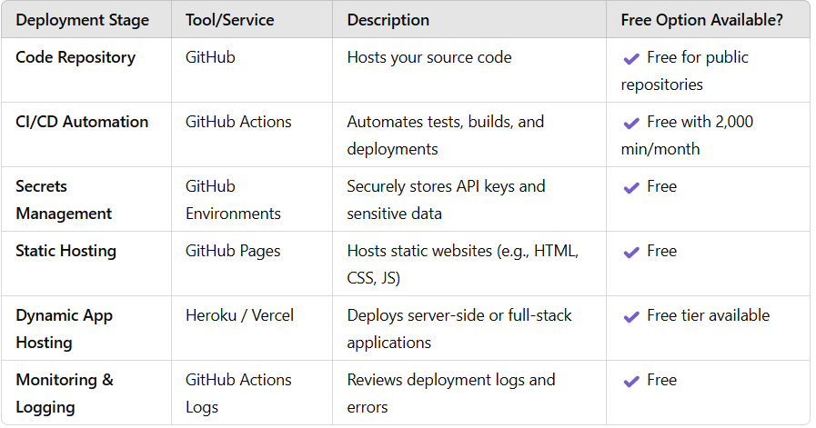**Use GitHub Actions logs for monitoring the deployment process and troubleshooting.**

***4.9 Free Deployment Stages and Tools***

**CHAPTER-15**

**Project Timeline &Development Workflow**

**15.1 Project Timeline with Development Phases**

The development of the VITM Web Application, Version 2.0, follows a structured timeline, divided into key phases:

* **Planning (2 Weeks)**
  + Requirements gathering, stakeholder meetings, and initial project scope definition.
  + Risk assessment and timeline creation.
* **Design (3 Weeks)**
  + Wireframe and mockup creation for each major module (Homepage, Admissions, Gallery, etc.).
  + User experience (UX) planning to ensure intuitive navigation.
  + Database and system architecture design.
* **Development (8 Weeks)**
  + **Frontend Development**: Building the user interface using HTML, CSS, JavaScript, and React.
  + **Backend Development**: API setup and data handling using Node.js or PHP, and integration with MySQL/MongoDB.
  + **Database Configuration**: Setting up database tables, relationships, and indexing.
* **Testing (3 Weeks)**
  + Unit, integration, and system testing using Jest, Mocha, and Selenium.
  + User acceptance testing (UAT) with sample user groups.
* **Deployment (1 Week)**
  + Final deployment to the live environment, including server configuration and domain setup.
  + SSL certificate installation and post-deployment testing for quality assurance.
* **Maintenance (Ongoing)**
  + Regular updates, bug fixes, and feature enhancements based on user feedback and needs.

**15.2 Gantt Chart or Timeline Diagram**

A Gantt chart illustrating these phases would break down each task within the phases, along with their respective timelines. Key milestones, such as **Design Approval**, **Backend Completion**, and **User Testing Completion**, would be highlighted to track progress and ensure on-time delivery.

**15.3 Agile Development Methodology**

The Agile development methodology is chosen for this project due to its adaptability and iterative approach:

* **Sprints**: Development is divided into two-week sprints, with specific objectives for each sprint (e.g., completion of Admissions module, setup of Result module).
* **Scrum Meetings**: Daily meetings (or stand-ups) ensure the team is aligned, with progress and any challenges discussed openly.
* **Feedback Integration**: At the end of each sprint, feedback is gathered, allowing adjustments to be made to meet project objectives effectively.

This approach ensures that the development process remains flexible and can respond to evolving requirements or feedback from stakeholders.

**15.4 GitHub for Version Control and Collaboration**

For effective version control and collaborative development, GitHub is used as the primary repository for the VITM Web Application project.

GitHub enables:

* **Code Management:** Each phase of the project is tracked through branches and pull requests, allowing individual team members to work on specific features or modules without impacting the main codebase.
* **Commit History:** A clear commit history is maintained to track changes, making it easy to revert to previous versions if needed.
* **Issue Tracking**: GitHub Issues are used to document tasks, bugs, and enhancement requests, allowing the team to prioritize and manage workflow efficiently.
* **Code Review and Pull Requests**: Team members submit their code for review through pull requests, which ensures quality and fosters a collaborative review process before merging changes into the main branch.

**15.5 Team Collaboration**

The project team consists of three members, each with defined roles and responsibilities:

* **Team Member 1 (Project Manager):** Responsible for planning, coordinating meetings, and managing timelines to ensure the project progresses on schedule.
* **Team Member 2 (Frontend Developer):** Focuses on building the user interface, creating engaging and user-friendly designs, and implementing responsive layouts using HTML, CSS, JavaScript, and React.
* **Team Member 3 (Backend Developer)**: Manages server-side development, API creation, and database configuration using Node.js or PHP with MySQL/MongoDB.

The team follows a collaborative approach, utilizing GitHub for real-time collaboration, ensuring code quality through regular reviews, and holding daily Scrum meetings to discuss progress and resolve any blockers.

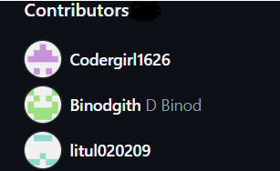

*fig 5.0 team collaborate*

**Conclusion and Recommendations**

**1.Summary of Project Success**

The VITM Web Application, Version 2.0, has successfully met the project’s objectives of delivering a user-friendly, secure, and fully functional digital platform for VITM Institute. The application provides essential services such as Admissions, Results, Announcements, and Events in a streamlined and accessible format. Key achievements include:

* **Enhanced Accessibility**: A responsive, mobile-friendly design that allows users to access information from any device.
* **Improved User Experience**: A clean, modular interface that simplifies navigation and interaction, especially for first-time visitors.
* **Robust Security**: Strong authentication and encryption measures that ensure data privacy and protect against cyber threats.
* **Efficient Administrative Tools**: Automation and self-service features that reduce the workload on administrative staff, supporting a more productive operational flow.

**2. Recommendations for Future Improvements**

To ensure the VITM Web Application continues to meet the evolving needs of its users, the following recommendations are proposed:

* **Develop a Dedicated Mobile Application**: Although the web application is mobile-responsive, a native mobile app could offer enhanced functionality and performance for mobile users.
* **Implement Advanced Analytics**: An analytics dashboard for administrators could offer insights into user engagement, helping VITM to adapt content and services to better meet user needs.
* **Add AI-Driven Chat Support**: An AI-based chatbot could provide round-the-clock support, answering user queries and providing guidance, particularly useful during high-traffic periods like admissions.
* **Consider LMS Integration**: In the future, an integration with a Learning Management System (LMS) could expand the application’s utility, allowing it to serve as a one-stop platform for all academic resources.

**REFERENCES**

1. **Books and Publications**
   * Smith, John. *Web Application Development with Node.js and React*. New York: TechBooks Publishing, 2022.
   * Kumar, A., and Patel, R. *Data Security in Web Applications*. San Francisco: CyberPress, 2021.
2. **Articles and Web Resources**
   * “Best Practices for Database Indexing and Normalization,” *Database Journal*, April 2023.
   * “Top UI/UX Design Trends for Educational Technology,” *EdTech Today*, October 2022.
   * GitHub Documentation. “Git Best Practices for Version Control.” Accessed June 2024. <https://docs.github.com>
   * JavaScript Documentation. “JavaScript Guide and Reference.” Accessed June 2024. <https://developer.mozilla.org/enUS/docs/Web/JavaScript>
   * Google Docs API Documentation. “Google Docs API Overview and Usage.” Accessed June 2024. https://developers.google.com/docs